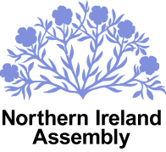

COMMITTEE FOR THE ENVIRONMENT

Please use this form to submit written submissions in relation to the Environmental Better Regulation Bill.

Return to committee.environment@niassembly.gov.uk

Name: _______________________________________________________________

Organisation: (if applicable) _____________________________________________

Date: ________________________________________________________________

For official use only
Date received: ____________________________________

Ref Number: ______________________________________

