LEGEND

DENOTES AREA TO BE ABANDONED
- 1616 m²

5

RK 3399
45
89

87
Ballyeaston Road

3377

3355
2299

CCRRAAIIGGHHIILLLL PPAARRKK

3300

3344
Area to be Abandoned

DEPARTMENT FOR INFRASTRUCTURE

Map No. IN1/26/626129 referred to in “The Craighill Park, Ballyclare (Abandonment) Order (Northern Ireland) 2026” made by the Department for Infrastructure on 2026 and coming into operation on 2027.

© Based upon the Ordnance Survey map with Permission of the Director and Chief Executive.

Crown copyright SCALE 1:1250

126

E R S K I N E P A R K
127

85

P3 | ISSUED FOR APPROVAL | 12.03.26 | SB | AH
P2 | ISSUED FOR APPROVAL | 19.02.26 | SB | AH
P1 | ISSUED FOR APPROVAL | 22.08.24 | SA | AH
Rev | Amendment | Date | By | Chk

107 Malone Avenue Belfast BT9 6EQ Tel: (028) 9066 7951 Fax: (028) 9066 4961
12 Windsor Terrace Derry BT48 7HQ Tel: (028) 7126 7115 Fax: (028) 7137 2466

Consulting Structural and Civil Engineers
www.taylor-boyd.co.uk

Project Title
Client/Arch
CRAIGHILL QUARRY, B'CLARE ABANDONMENT PLAN
MAR / FORMATIVE ARCHITECTS

Scale (@ A4)

1:1250

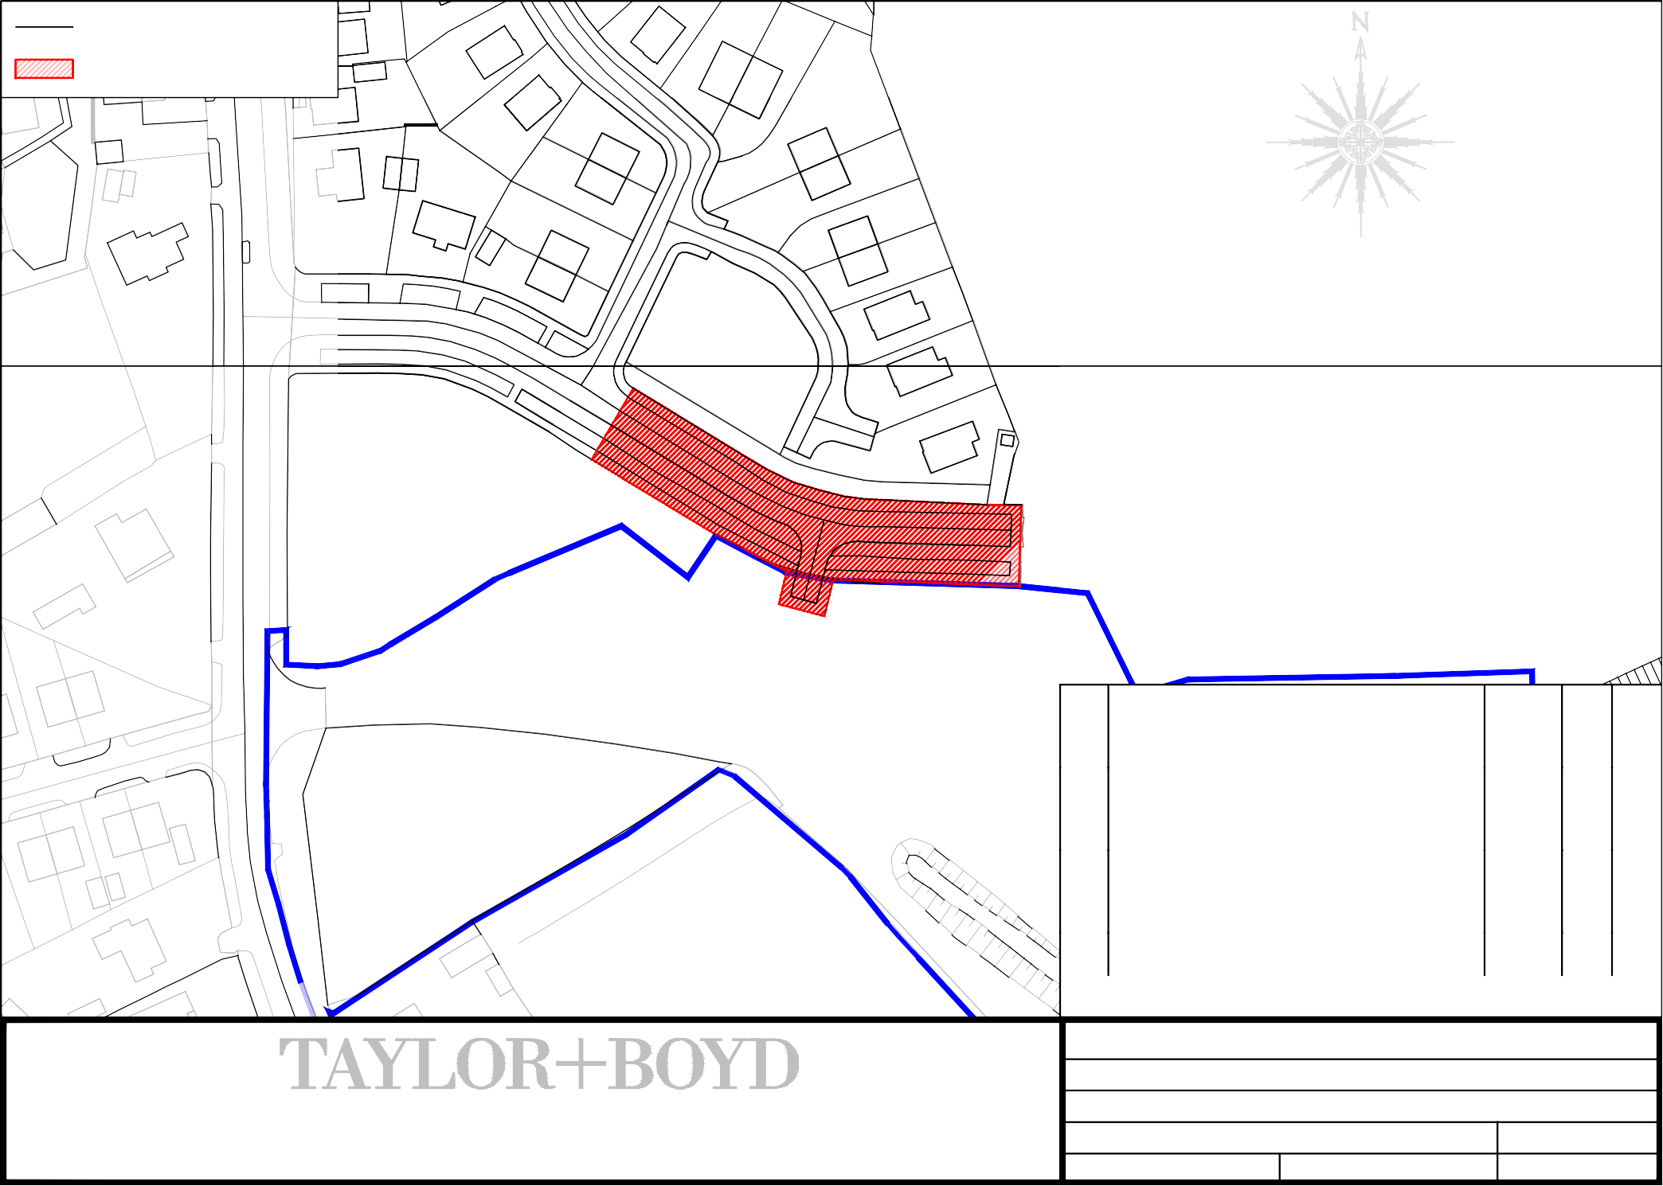
Drawn SA
Checked AH
Drg No.
17782-C312 P3

