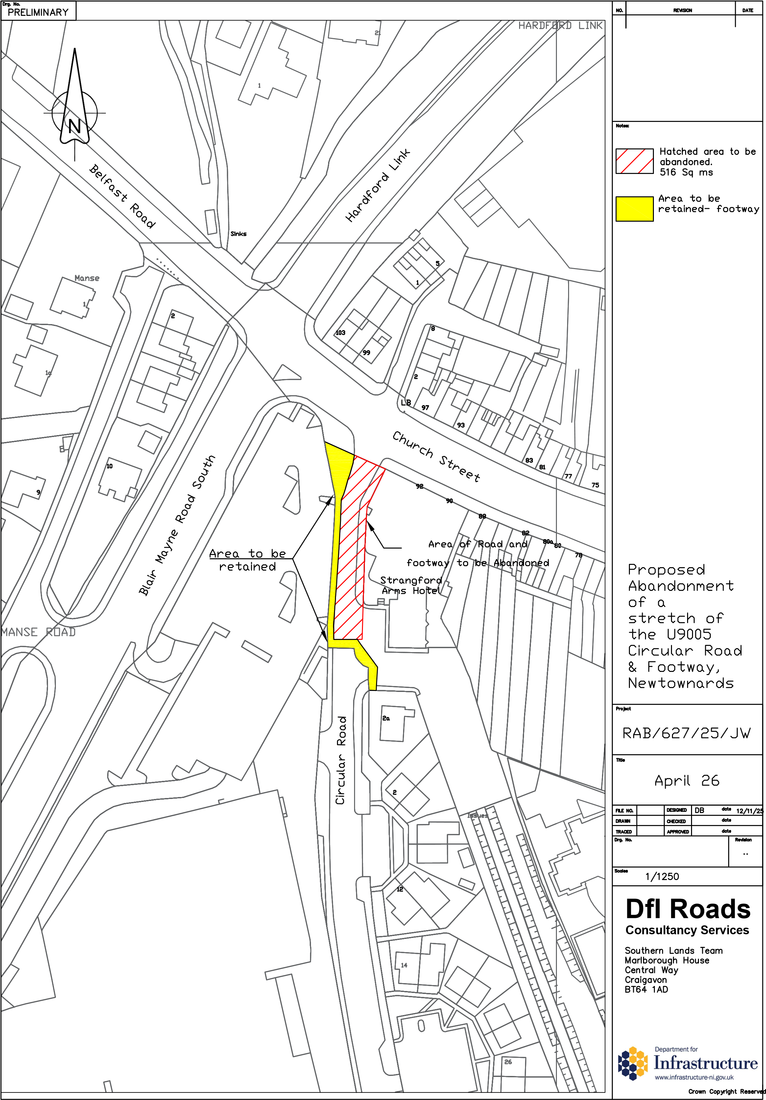
AREA TO BE ABANDONED
DEPARTMENT FOR INFRASTRUCTURE
Map No. IN1/26/443197 referred to in “The Circular Road, Newtownards (Abandonment) Order (Northern Ireland) 2026” made by the Department on 2026 and coming into operation on 2026.
©Based upon the Ordnance Survey map with the Permission of the Director and the Chief Executive.
Crown Copyright SCALE 1:1250

