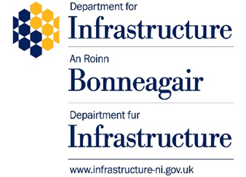

Synopsis of Responses
A consultation on proposals on changes to regulations to support the uptake of zero emission goods vehicles (ZEGVs) in Northern Ireland

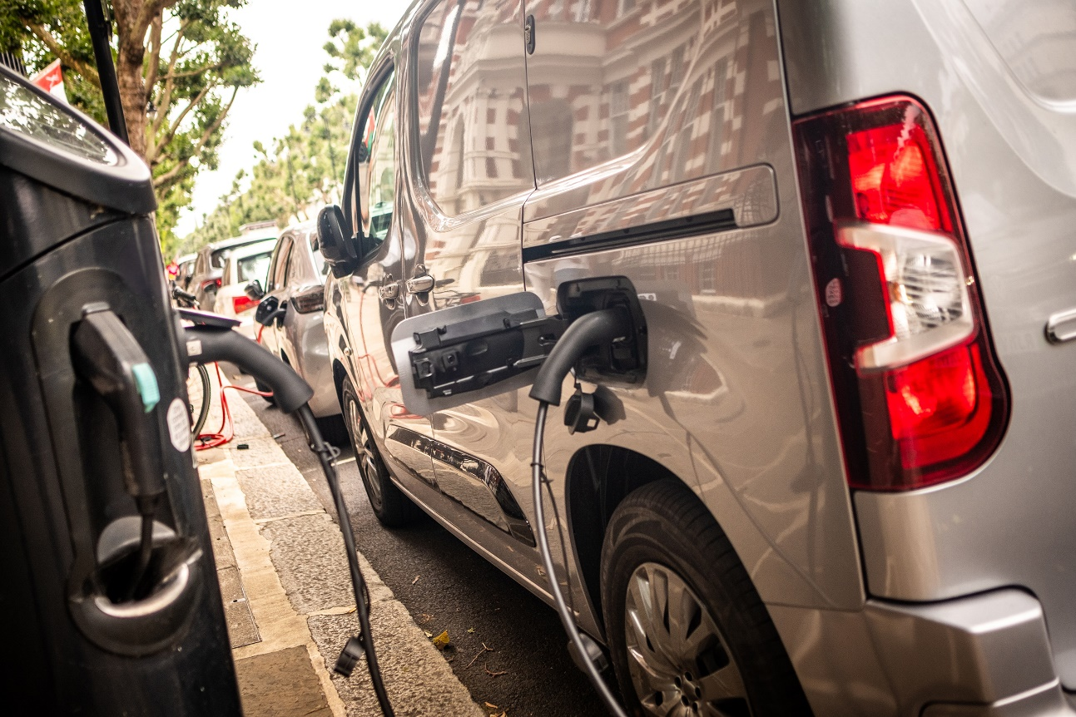
Date: xx May 2026

Contents
This synopsis is divided into the following sections:

Executive Summary 3
- Introduction and Overview 5
- Analysis of Consultation Feedback and DfI response 5
- Next steps 11
- Annex A – Consultation Questions 12
- Annex B - List of Organisations who responded to the Consultation 13

Executive Summary
On 10 March 2026, the Department for Infrastructure (DfI) launched a four-week public consultation on proposals to amend driver licensing regulations to support the uptake of zero emission goods vehicles (ZEGVs) in Northern Ireland. The consultation closed on 6 April 2026
The consultation sought views on whether amendments to category B licence entitlements could address unintended regulatory barriers arising from the additional weight of zero emission technology, while continuing to ensure that road safety remains a central consideration.
A total of 26 formal responses were received, comprising responses from 12 individuals and 14 organisations. Respondents included members of the public, trade bodies, fleet operators, utility providers, retailers, local authorities and representative organisations. A list of the consultation questions asked is at Annex A. Details of the organisations that responded to the consultation is attached at Annex B.
Responses demonstrated strong support for the proposals. A clear majority of respondents agreed that increasing the maximum authorised mass (MAM) of ZEGVs that can be driven on a category B licence from 3,500kg to 4,250kg would help remove barriers to ZEGV adoption created by the additional weight of battery technology, while recognising that these vehicles are broadly equivalent in size and function to their conventional diesel or petrol counterparts.
There was also broad support for:
- applying the change across all ZEGVs up to 4,250kg;
- providing an enhanced 5,000kg MAM allowance where additional weight is attributable to specialist equipment for disabled users; and
- permitting towing, including vehicle and trailer combinations up to 7,000kg MAM subject to the appropriate B+E licence entitlement.
Respondents identified a range of anticipated benefits, including operational efficiency, improved payload capacity, reduced costs for businesses and drivers, and support for the transition from diesel to zero‑emission fleets. Many organisational respondents also highlighted the importance of regulatory alignment with Britain, noting that consistency across jurisdictions would reduce complexity for operators and support wider adoption of ZEGVs.
A small number of respondents raised concerns and these focused primarily on:
- potential road safety implications associated with increased vehicle mass;
- the limited availability of Northern Ireland–specific evidence on collision impacts;
- concerns relating to rural infrastructure and charging availability; and
- the clarity and definition of certain proposals, particularly in relation to higher weight allowances and specialist equipment.
These views were taken into account and considered as part of the overall consultation analysis.
Opinion was more divided on the proposal to limit entitlement to drivers who have held a full category B licence for a minimum of two years. While a majority of respondents supported this as a proportionate road safety safeguard, others questioned whether licence duration alone is an effective indicator of competence. They highlighted differences between the position here and in Britain and raised concern that the divergence from the approach adopted in Britain could disadvantage younger drivers or create inefficiencies for fleet operators.
Having considered all responses, the Department has concluded that the proposals set out in the consultation provide a balanced approach to supporting the uptake of ZEGVs while maintaining appropriate safeguards and recognising the importance of road safety.
The Department will therefore proceed with legislative amendments to:
- increase the category B weight limit for ZEGVs to 4,250kg MAM;
- introduce a two-year licence-holding requirement for drivers using this entitlement;
- permit category B drivers to operate ZEGVs up to 5,000kg MAM where the additional weight is attributable to specialist equipment for disabled users; and
- permit towing in line with defined conditions.
The Department will continue to monitor implementation and emerging evidence, including road safety data, as ZEGVs become more prevalent on the road network in the north.

Introduction And Overview

On 10th March 2026 the Department for Infrastructure (DfI) launched a 4-week public consultation seeking views on proposed changes to regulations to support the uptake of zero emission goods vehicles (ZEGVs) in Northern Ireland. The consultation closed on 6th April 2026.

The purpose of this report is to provide a summary of the analysis of the responses to that consultation and to outline the Department’s next steps.

A total of 26 formal responses were received. Of these, 21 responses were submitted via the Citizen Space consultation portal and 5 responses were received via e-mail. Respondents comprised 12 individuals and 14 organisations, including an EV charging infrastructure provider (Go Eve Ltd.), an infrastructure and engineering service provider (Circet), a fleet technology and consultancy provider (Genie Insights Ltd.),trade bodies (Logistics UK and The Society of Motor Manufacturers and Traders Limited (SMMT)) a local authority (Mid-Ulster Council), a political party (Alliance Party), a utility provider (Openreach), a retailer (Tesco Stores Ltd.), a commercial vehicle dealer and service provider (Diamond Trucks) and representative organisations (Confederation of British Industry Northern Ireland (CBI), Community Transport Association (CTA), Consumer Council and Greentown Environmental).
Analysis of Consultation Feedback and DfI response
Annex A provides a summary of the consultation questions that were asked.
Question 1
Do you agree with our proposal to increase the weight limit of ZEGVs that can be driven on a category B driving licence from 3,500kg to 4,250kg, in Northern Ireland?
All 26 respondents answered this question.
- 24 respondents (92%) agreed with the proposal
  - 11 individuals
  - 13 organisations
- 2 respondents (8%) did not agree
  - 1 individual
  - 1 organisation (Community Transport Association – CTA)
Comments were invited from those who were not in favour of this proposal. Responses raised concerns regarding:
- road safety and increased vehicle mass; and
- the lack of Northern Ireland–specific evidence to demonstrate safety, environmental, or economic benefits (CTA).
Departmental Response
This is an emerging market and there is currently very limited Northern Ireland specific data available for these 3,500kg - 4,250kg zero emission goods vehicles (ZEGVs) due to there only being 197 licenced here as of September 2025, according to the most recent vehicle licensing statistics.
The Northern Ireland figures for zero emission goods vehicles were produced by the DVA Statistics Branch using administrative vehicle licensing data supplied by the Department for Transport (DfT) under an information sharing agreement. The underlying dataset is not publicly accessible. While Northern Ireland licensing statistics are included within the UK vehicle licensing tables published by DfT, the published tables do not provide sufficient detail to identify vehicles by both propulsion type and precise vehicle weight band. As such, the figures presented here cannot be reproduced directly from published data sources.
Vehicle propulsion data is not currently collated as part of the vehicle collision statistics here. It is therefore not possible to determine if any of these vehicles have been involved in any collisions to date or to draw any conclusions on the severity of those collisions in comparison to their Internal Combustion Engine (ICE) equivalents.
One consultation response noted that “4.5t electric vehicles have formed part of the Tesco fleet for 5 years and we have not seen any increase in accidents or collisions when compared to the ICE vehicles that were previously used.”. They also noted that data provided to the UK DfT by operators with fleets containing a mix of 3.5 to 4.25t ZE vans and ICE equivalents up to and including 3.5t, including Tesco, via the 'Zero Emission Goods Vehicles: Regulatory Flexibility' consultation, which closed in March 2025, showed no increase in collision rate for the heavier ZE vans.
It was also noted that the implementation of the category B 4,250kg derogation in Britain in 2018 had not triggered any post-implementation safety issues.
The Department recognises the limited availability of Northern Ireland–specific datasets at present. To help mitigate these risks Department officials will look to expand the data collected and to monitor road collision data going forward.
Having considered the responses received, the Department will proceed with legislative changes to increase the weight limit of ZEGVs that can be driven on a category B licence from 3,500kg to 4,250kg in Northern Ireland.

Question 2
Do you agree that the proposed change should apply only to drivers who have held their full category B driving licence for at least two years?
Of the 24 respondents who answered this question:
- 17 respondents (71%) agreed
  - 10 individuals
  - 7 organisations
- 7 respondents (29%) disagreed
  - 2 individuals
  - 5 organisations
Comments were invited from those who were not in favour of this proposal. Those opposed raised concerns that:
- Licence duration does not equate to competence (CTA)
- The requirement may indirectly disadvantage younger drivers from starting a career in logistics (TESCO)
- Britain has removed equivalent restrictions (SMMT)
- Adopting a different approach to Britain may increase complexity for fleets operating across jurisdictions (SMTT)
Departmental Response
Having considered the responses and available road safety statistics, including the PSNI road traffic collision records and Driver Licensing System records, the Department will proceed to legislate to provide for the introduction of a requirement that drivers must have held a full category B licence for at least two years before driving a ZEGV up to 4,250kg under the revised entitlement.

Question 3
Do you agree that category B licence holders, should be allowed to drive a ZEGV up to a MAM of 5,000kg where the additional 750kg are attributed to specialist equipment for disabled users?
Of the 24 respondents who answered:
- 22 respondents (92%) agreed
  - 11 individuals
  - 11 organisations
- 2 respondents (8%) disagreed
  - 1 individual
  - 1 organisation

Support was expressed on accessibility and equality grounds.
Those who were not in agreement raised a number of objections related primarily to a lack of clarity regarding:
- Definition of “specialist equipment” (CTA);
- Oversight and enforcement; and
- Safety evidence specific to higher-weight vehicles.
Departmental Response
The Department has considered the objections raised and will give further consideration to these matters, including comparing the approach to these matters as applied in GB, and produce guidance where considered necessary. However, in light with the significant level of support for this proposal, the Department will proceed to legislate to allow category B licence holders to drive ZEGVs up to 5,000kg MAM where the additional weight is attributable to specialist equipment for disabled users.

Types of vehicles that should be eligible
Question 4
Should the proposed changes be applied to all ZEGVs?
Of the 25 respondents who answered:
- 23 respondents (92%) agreed with the proposal
  - 11 individuals
  - 12 organisations
- 2 respondents (8%) did not agree
  - 1 individual
  - 1 organisation

Question 5
If no to Q4, should the changes be applied to only those ZEGVs transporting goods?
Only 5 respondents answered this question:
- 2 respondents (40%) agreed with the proposal
  - 1 individual
  - 1 organisation
- 3 respondents (60%) did not agree
  - 2 individuals
  - 1 organisation
The responses received included a request to permit Internal Combustion Engine (ICE) motorhomes up to 4,250kg to be driven on a category B driving licence, in Northern Ireland. However, as this consultation was on proposed changes to legislation to support the uptake of ZEGVs, and to help deliver against environmental commitments made by the NI Executive through their endorsement of the UK Government’s Zero Emission Vehicle (ZEV) Mandate from 1 January 2025, consideration of this rests outside the scope of the consultation.
Departmental Response
Following consideration of the consultation responses, and in line with the significant level of support for this proposal, the Department will proceed with legislation to apply the revised weight limit to all ZEGVs and not just those used for the transportation of goods.

Towing allowance of these vehicles
Question 6
Should a category B licence holder who is operating a ZEGVs, weighing between 3,500kg and 4,250kg, be allowed to tow a trailer where the trailer has a MAM not exceeding 750kg?
Of the 24 respondents who answered:
- 21 respondents (88%) agreed
  - 11 individuals
  - 10 organisations
- 3 respondents (12%) disagreed
  - 1 individual
  - 2 organisations
Those who were not in support of this proposal reflected the view that the legislation should align across all UK jurisdictions (i.e. the same rules are applied as laid out in SI 2025 No. 608) (SMMT) and that allowing heavier ZEGVs to tow trailers introduces additional operational risks, including increased braking distances, reduced stability, and higher driver skill requirements (CTA).

Departmental Response
Following consideration of the responses, and in line with the significant level of support for this proposal, the Department will proceed with legislation to allow a category B licence holder who is operating a ZEGVs, weighing between 3,500kg and 4,250kg, to tow a trailer where the trailer has a MAM not exceeding 750kg.

Question 7
Should a category B licence holder who is operating a ZEGV weighing between 3,500kg and 4,250kg, be allowed to operate a vehicle and trailer combination up to 7,000kg MAM, on passing a B+E test?
Of the 25 respondents who answered:
- 23 respondents (92%) agreed
  - 12 individuals
  - 11 organisations
- 2 respondents (8%) disagreed
  - 2 organisations
Comments from those in support of this proposal, which included Go Eve Ltd., Logistics UK, SMMT and Genie Insights Ltd., reflected that this proposal represented an operational necessity for fleets, it would result in the removal of some licensing burdens and that the ZEGVs, due to their floor-mounted batteries, would provide a more stable towing platform than their diesel equivalents.:
Concerns related to:
- Increased operational complexity (CTA)
- Additional operational risks, including increased braking distances, reduced stability, and higher driver skill requirements Braking distances and stability (CTA)
- Lack of NI-specific safety analysis (CTA)
Departmental Response
Following consideration of the responses received, and in line with the significant level of support for this proposal, the Department will permit towing in line with the proposals, including vehicle-and-trailer combinations up to 7,000kg MAM subject to the appropriate B+E entitlement.

Questions 8–10: Impacts, Evidence, and Additional Comments
Respondents highlighted:
- Economic benefits: reduced fleet costs, improved productivity, reduced journeys
- Environmental benefits: fewer vehicles, lower emissions, accelerated fleet transition
- Operational considerations: vehicle range when towing, charging availability (particularly in rural areas)
- Safety considerations: vehicle handling, trailer stability, road wear
Several organisations called for:
- Ongoing monitoring of collision data
- Greater availability of Northern Ireland-specific evidence
- Alignment with legislation/policy in Britain to reduce complexity
Departmental Response
Impacts were considered when developing the consultation proposals with supplementary screening conducted throughout, and following the completion of, the consultation exercise and the drafting of the legislation. As part of this process the Department considered the information provided during this consultation process in its review of the Equality, Rural Needs, Human Rights and Regulatory impact assessments.
It recognises that limited NI specific data is currently available and will consider emerging NI specific data as ZEGVs become more prevalent on the roads network.

Next Steps
Following consideration of the responses, the Department will bring forward amending legislation at the earliest opportunity to:
- Increase the category B ZEGV weight limit to 4,250kg
- Introduce a two-year licence-holding requirement
- Provide a 5,000kg allowance for ZEGVs adapted for disabled users
- Permit towing under defined conditions
The Department will continue to monitor road safety outcomes and operational impacts as these changes are implemented.
Annex A – Consultation Questions

Legislative change
Q1– Do you agree with our proposal to increase the weight limit of ZEGVs that can be driven on a category B driving licence from 3,500kg to 4,250kg, in Northern Ireland?
Q2 – Do you agree that the proposed change should apply only to drivers who have held their full category B driving licence for at least two years?
Q3 – Do you agree that category B licence holders, should be allowed to drive a ZEGV up to a MAM of 5,000kg where the additional 750kg are attributed to specialist equipment for disabled users?

Types of vehicles that should be eligible
Q4 Should the proposed changes be applied to all ZEGVs?
Q5 If no to Q4, should the changes be applied to only those ZEGVs transporting goods?

Towing allowance of these vehicles
Q6 Should a category B licence holder who is operating a ZEGVs, weighing between 3,500kg and 4,250kg, be allowed to tow a trailer where the trailer has a MAM not exceeding 750kg?
Q7 Should a category B licence holder who is operating a ZEGV weighing between 3,500kg and 4,250kg, be allowed to operate a vehicle and trailer combination up to 7,000kg MAM, on passing a B+E test?
Q8 Can you explain and quantify any advantages and disadvantages (e.g. economic, environmental, safety) of allowing ZEGVs weighing between 3,500kg and 4,250kg to tow a trailer?
Q9 Is there any relevant data or research in relation to the impact of ZEGVs on road safety that the Department should take into consideration?
Q10 Do you have you any other comments on the proposals contained in this consultation, including any potential impacts you feel there may be on any Section 75 Groups? (religious belief, political opinion, racial group, gender, disability, age, marital status, dependents and sexual orientation)?

Annex B - List of Organisations that responded to the Consultation
- Alliance Party
- Confederation of British Industry Northern Ireland (CBI NI)
- Circet
- Community Transport Association (CTA)
- Consumer Council
- Diamond Trucks
- Genie Insights Ltd.
- Go Eve Ltd.
- Greentown Environmental
- Logistics UK
- Mid-Ulster District Council
- Openreach Northern Ireland
- Tesco Stores Limited
- The Society of Motor Manufacturers and Traders Limited (SMMT)

