NOTES

- Verifying Dimensions.
The contractor shall verify dimensions against such other drawings or site conditions as pertain to this part of the work.

- Existing Services.
Any information concerning the location of existing services indicated on this drawing is intended for general guidance only. It shall be the responsibility of the contractor to determine and verify the exact horizontal and vertical alignment of all cables, pipes, etc. (both underground and overhead) before work commences.

- Issue of Drawings.
Hard copies, dwf and pdf will form a controlled issue of the drawing. All other formats (dwg, dxf etc.) are deemed to be an uncontrolled issue and any work carried out based on these files is at the recipients own risk. RPS will not accept any responsibility for any errors arising from the use of these files, either by human error by the recipient, listing of un-dimensioned measurements, compatibility issues with the recipient's software, and any errors arising when these files are used to aid the recipients drawing production, or setting out on site.

- Datum.

Existing Survey

Proposed Layout

Stopping up commencing at the
point shown on layout - Length - 26.8m A B

Stopping up commencing at the
point shown on layout - Length - 6.8m C D

Stopping up commencing at the
point shown on layout - Length - 6.6m E F
Stopping up commencing at the
point shown on layout - Length - 46.5m G H

Area to be Abandoned - 608m²

PLOT 1 TO BE ABANDONED AND LENGTHS A-B AND C-D TO BE STOPPED-UP

A

B D
Plot 1 - 46m² C

ALTERNATIVE ROUTE

F

E C1
rev
Construction Issue amendments
OW
check
June 24 date

G

Plot 2 - 562m²
DEPARTMENT FOR INFRASTRUCTURE
Map No. IN1/25/648952 referred to in “The Comber Road, Dundonald (Abandonment and Stopping-Up) Order (Northern Ireland) 2026” made by the Department on 2026 and coming into operation on 2026.
©Based upon the Ordnance Survey map with the Permission of the Director and the Chief Executive.
Crown Copyright SCALE 1:500

Client

Elmwood House 74 Boucher Road Belfast
BT12 6RZ

T +44 (0) 28 90 667914
F +44 (0) 28 90 668286
W www.rpsgroup.com/ireland
E ireland@rpsgroup.com

Lagan Homes Ltd.

Project

Millmount Externals - Comber Road
_{H} Realignment
Title

Proposed Abandonment

Project Number Sheet Size Drawing Scale

IBH0784 A1 1:500
PLOT 2 TO BE ABANDONED AND LENGTHS E-F AND G-H TO BE STOPPED-UP
Drawing Number

IBH0784-RPS -HGN -J3-DR-HE-100-00001

Drawn By
Status
Revision

RD A C1

10m SCALE 1:500
Checked By
Approved By
Date









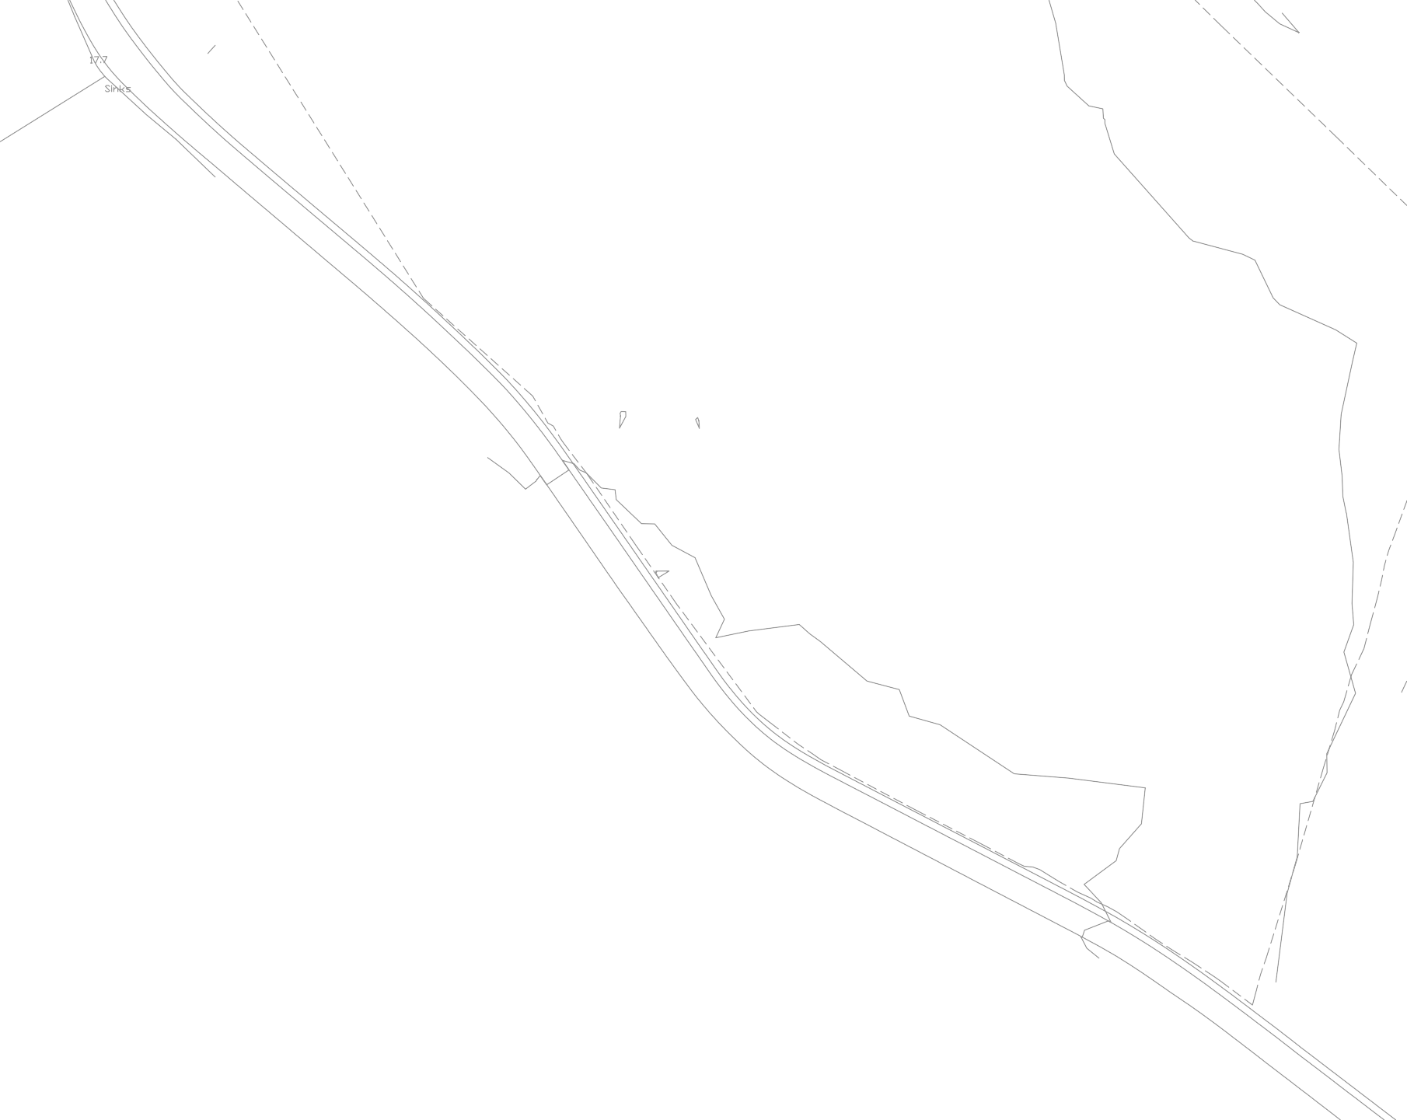
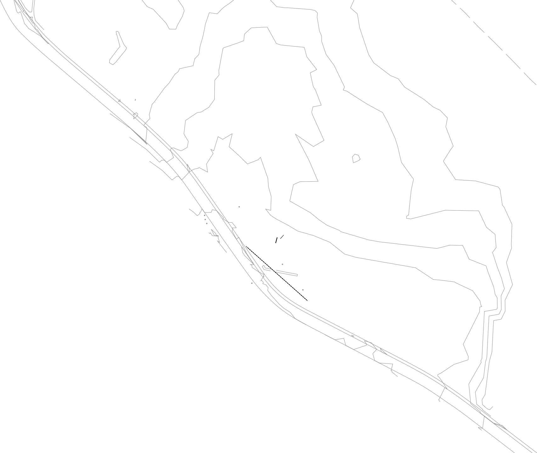

















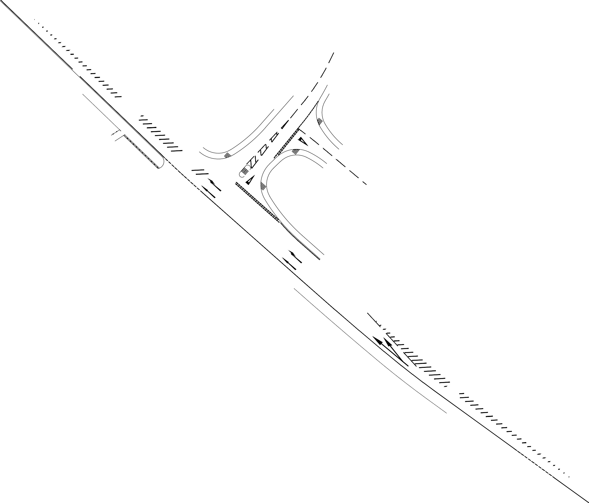



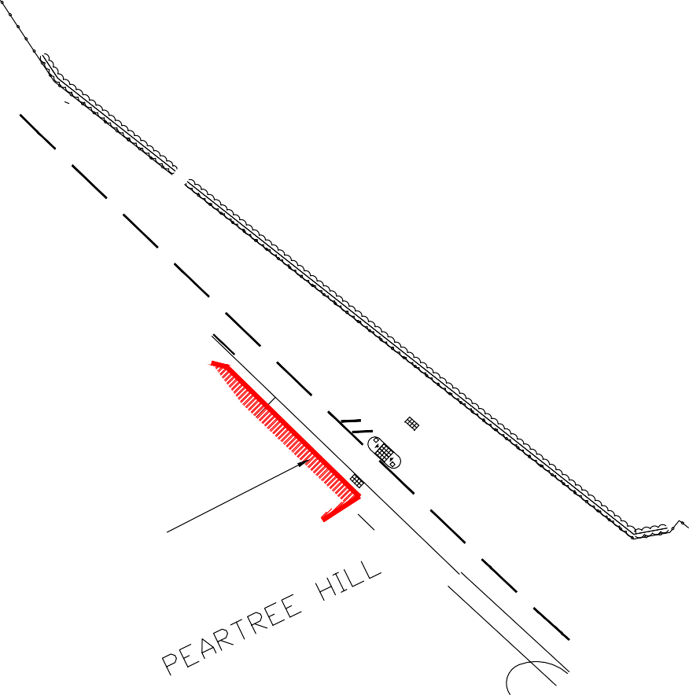
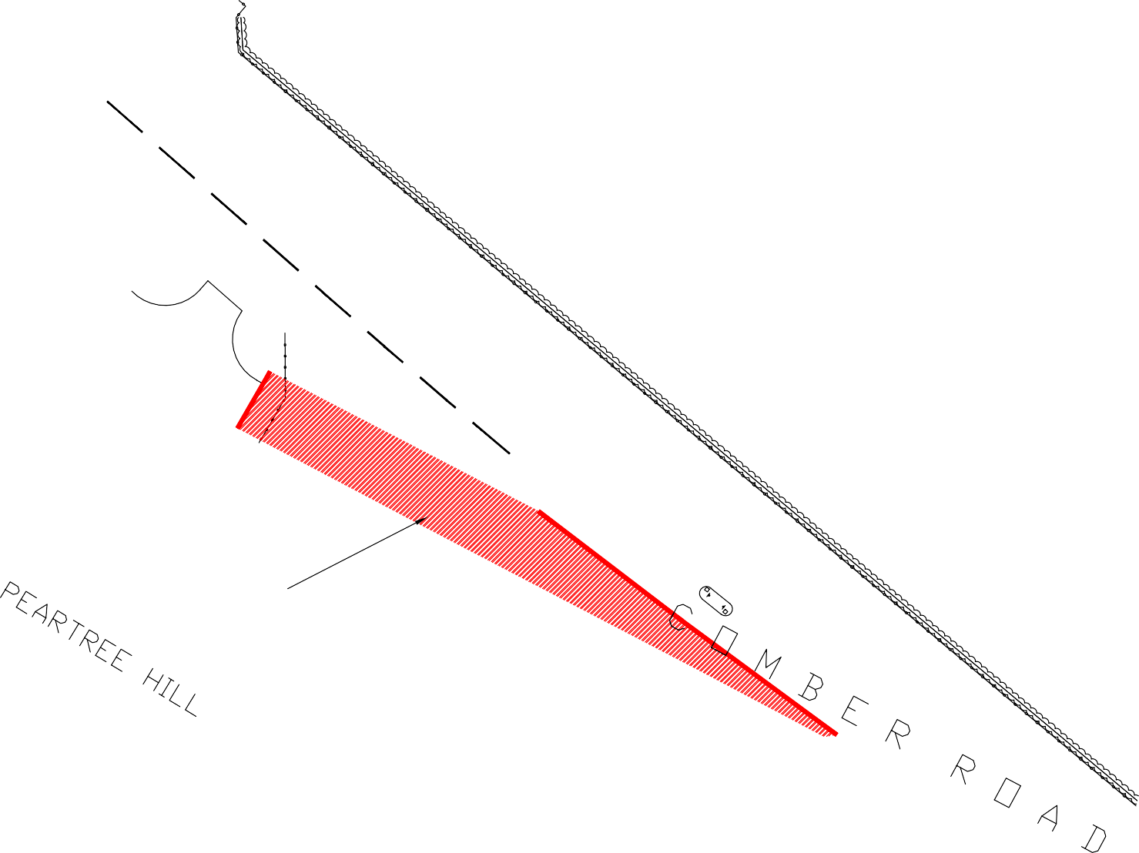



MMcG JB July 24

