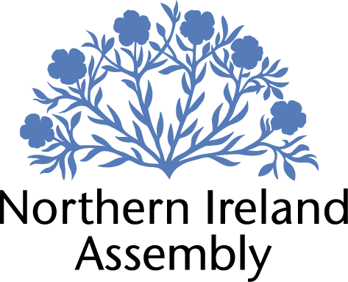

APPLICATION FOR FILMING AT PARLIAMENT BUILDINGS

Name of Organisation / Individual: __________________________________________________________________

Email address: __________________________________________________________________

Telephone number: __________________________________________________________________

Purpose of filming (Please note that films that benefit commercial advancement only etc… will not be permitted): ___________________________________________________________________

Type of film (i.e., political programme / film / documentary): ____________________

___________________________________________________________________

Proposed dates for filming: ___________________________________________________________________

Duration of filming: ___________________________________________________________________

Location (i.e. Great Hall, outside front steps, Committee Rooms etc…): ___________________________________________________________________

___________________________________________________________________

______

Proposed content and contributors: ___________________________________________________________________

___________________________________________________________________
___________________________________________________________________

___________________________________________________________________

___________________________________________________________________

Production crew (Names, phone numbers, titles):______________________________________________________________
___________________________________________________________________

___________________________________________________________________

Relevance of film to Parliament Buildings/the Northern Ireland Assembly:___________________________________________________________
___________________________________________________________________

What props/equipment do you intend to use/bring into Parliament Buildings? ___________________________________________________________________

___________________________________________________________________

Will you require footage of the Assembly (i.e. plenary sessions/committee meetings)? __________________________________________________________
How will this footage be used? ___________________________________________________________________

___________________________________________________________________

Any other details: ___________________________________________________________________
___________________________________________________________________

I have read the following and hereby:

Agree that no insignia / regalia will be used as detailed in the Policy on the Conduct and Behaviour of Visitors in Parliament Buildings.

Give my assurance that any filming will not be used inappropriately or in any way that may have an impact on the dignity of the Northern Ireland Assembly and / or Parliament Buildings.

_______________________________________ (Signed/Dated by the Organiser)

_______________________________________ (Signed/Dated on behalf of the Assembly)

Please note: If you require further information regarding accessibility of Parliament Buildings please visit the Assembly website at http://www.niassembly.gov.uk/visit-and-learning/accessing-parliament-buildings/

