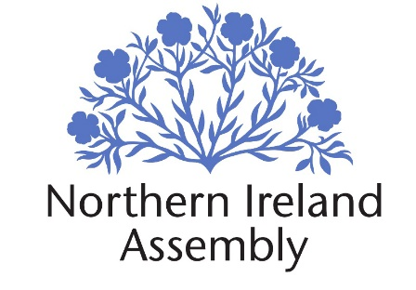
Northern Ireland Assembly Media Handbook/Code of Conduct Agreement:
I confirm that I have received and read a copy of the Northern Ireland Assembly Media Handbook and that I am fully aware of its terms and conditions and my responsibilities as a media pass holder as contained therein.
I further understand that failure to comply with the directives set out in the Northern Ireland Assembly Media Handbook or any alleged breaches of the Code of Conduct will be notified to my employer or (if freelance) to my sponsoring organisation and to the Northern Ireland Assembly’s Head of Communications. The Head of Communications can enforce a sanction which may include the withdrawal of media access. Breaches of the Code of Conduct will be recorded and reviewed for monitoring purposes.
I understand that compliance with the directives as specified in the Media Handbook and the Code of Conduct is a condition of my retaining an Assembly media pass.

Name:

Signature:

Contact details:

Email address:

Employer/ Sponsoring Organisation:

Address:

Telephone Number:

Date:

