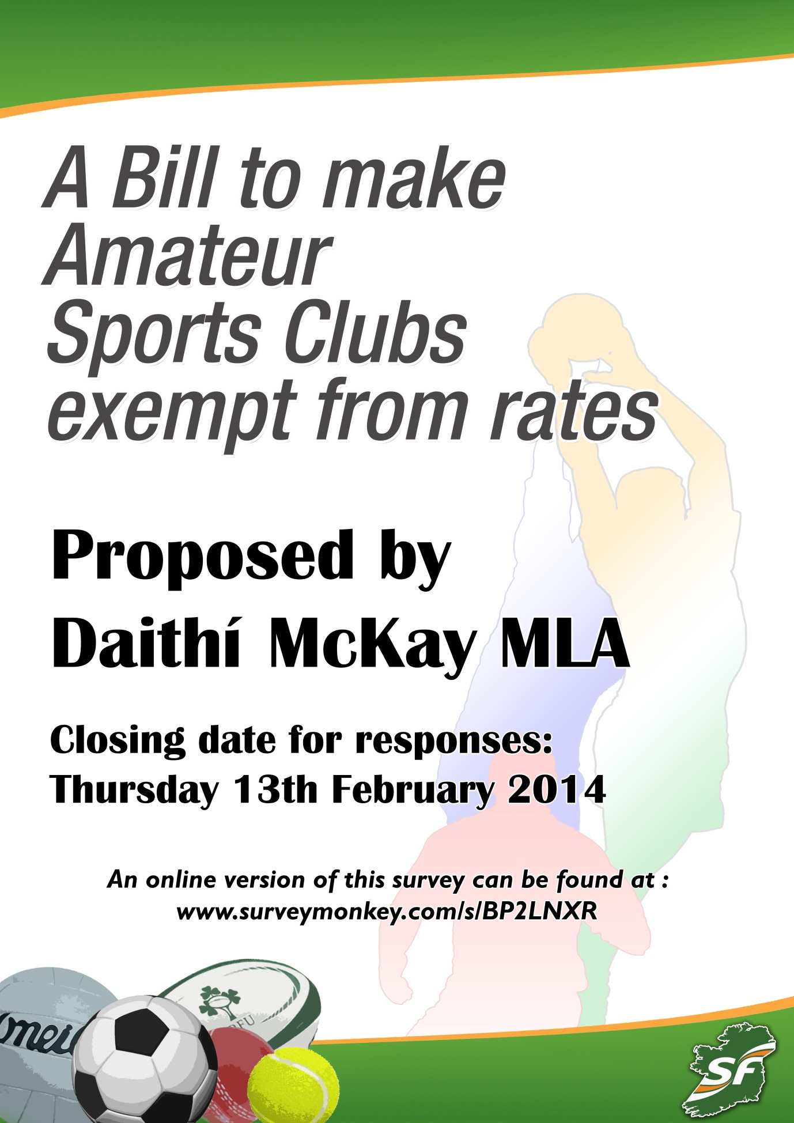
AMATEUR SPORTS CLUBS
Amateur sports are sports in which participants engage largely or entirely without remuneration. The distinction is made between amateur sporting participants and professional sporting participants, who are financially remunerated for the time they spend playing or training.
WHAT RATES DO AMATEUR SPORTS CLUBS PAY?
The current position in the north is that all Amateur Sports Clubs can avail of 80% rates relief. This is legislated for under the Rates (NI) Order 1977.
WHAT ARE CASCs?
The Community Amateur Sports Club Scheme (CASC) was introduced in April 2002. This has enabled many local amateur sports clubs to register with Revenue & Customs (HMRC) and benefit from a range of tax reliefs, including Gift Aid.
WHAT CLUBS ARE ELIGIBLE?
The conditions for becoming a CASC are fairly easy to meet. Your club must fit in with these in practice as well as having these as requirements in the club rules. A club must:
•be open to the whole community
•be organised on an amateur basis
•have as its main purpose providing facilities for, and promoting participation in one or more eligible sports
•meet the location requirement
•meet the management condition

THE CASE FOR CHANGE
Amateur sports clubs are already entitled to 80% Rate Relief which was introduced in recent years to support grass roots sport.
In the rest of Ireland land is exempt from paying commercial rates if it is developed for sport (Schedule 4 of the Land Valuation Act 2001)
In Scotland, England and Wales CASCs receive 80% rate relief but, in contrast to here, local authorities have the discretion to increase the relief up to 100%.
Amateur Sports Clubs have seen their income severely reduced in recent years. In many rural areas clubs struggle to field a full team because young members have emigrated to find work in other countries.
Because of the economic downturn clubs receive less financial support from local businesses many of which have seen profits reduced or have had to fold in an environment of reduced demand for their services.
In 2011 the Assembly debated a motion calling for the rate relief for amateur sports clubs to be extended from 80% to 100%. The Assembly agreed to call on the Finance Minister ‘to examine the rate relief afforded to these clubs’.
THE PROPOSAL
I am bringing forward a Private Members Bill to the Assembly that will make Amateur Sports Clubs exempt from rates.
I believe that this will help to keep many clubs afloat financially and it will also demonstrate that we recognise the contribution that volunteers in sports clubs make to society and their communities.
I would greatly appreciate it if you would complete the following questions as part of my consultation seeking the views of sporting organisations, other groups and members of the public.
Daithí McKay MLA
Please respond to :
Daithí McKay MLA
Parliament Buildings
Ballymiscaw
Stormont
Belfast
BT4 3XX
Email : daithimckay@btinternet.com
Closing date for responses : Thursday 13th February 2014

1. Do you support the proposal to make Amateur Sports Clubs exempt from rates?
Yes
No
Unsure
Comments : _____________________________________________________________________________________________________________________________________________________________________________________________________________________________________________________________________________________________________________________________________________________________________________________________________________________

2. Do you agree that this legislation is the best way to address this issue?
Yes
No
Unsure
Comments :
_____________________________________________________________________________________________________________________________________________________________________________________________________________________________________________________________________________________________________________________________________________________________________________________________________________________

3. Do you think that the Rates (NI) Order 1977 should be amended to ensure that all Community and Amateur Sports Clubs are fully exempt from rates? If the Bill were to include this then clubs would have to register as a Community and Amateur Sports Club before they could qualify for rates exemption.
Yes
No
Unsure
Comments :
_____________________________________________________________________________________________________________________________________________________________________________________________________________________________________________________________________________________________________________________________________________________________________________________________________________________

4. Do you believe Amateur Sports Clubs contribute to any of the following?
Improved Public Health
Better Community Relations
Individual Discipline
Less anti-social behaviour
Greater appreciation of local community
Increased activities for young people

5. How do you think the proposed legislation will impact on human rights?
Positively
Negatively
Not at all / not significantly
Unsure
6. How do you think the proposed legislation will impact on equality of opportunity?
Positively
Negatively
Not at all / not significantly
Unsure
7. Do you have any other comments on the proposed legislation?
Comments :
_____________________________________________________________________________________________________________________________________________________________________________________________________________________________________________________________________________________________________________________________________________________________________________________________________________________

Name / Name of organisation : ________________________________
Address : __________________________________________________
Contact Number : ___________________________________________
Email : ____________________________________________________

