NORTHERN IRELAND ASSEMBLY
Guidance for external candidates on completing the online application form
The Human Resources Office advice is always that applicants should give themselves plenty of time to complete and submit their application form. The closing time for all competitions is midnight on the date specified in the job notice. If you experience any problems in using the system please contact the Human Resources Office on 02890 521699 and staff will be available to assist you during normal working hours (0900-1700). When you click on the link to the online application form on the NI Assembly website, the following screen will appear.
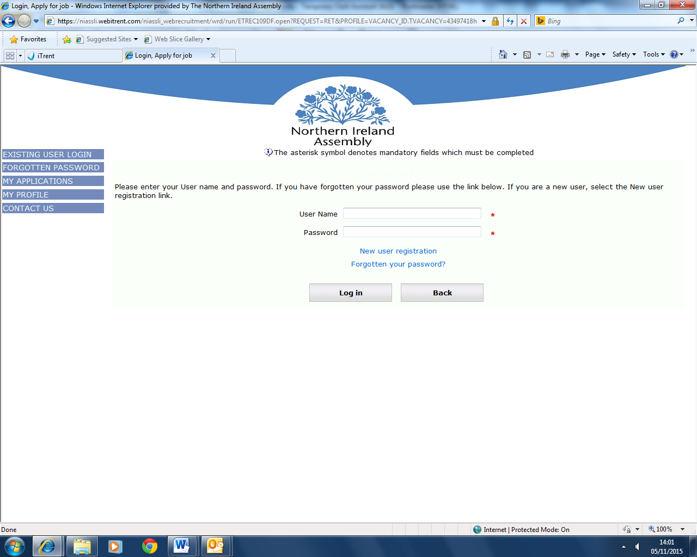
Please set up a new user account by clicking on the ‘New user registration’ link as shown on the screen shot above.
Fill in the details as requested in relation to personal details, reasonable adjustments and/or guaranteed interview scheme using the ‘next’ button to move to the next part of the form. The ‘save’ button should be used if an applicant wishes to exit out of a form and come back to it at a later time.
We have been made aware by our software supplier that the use of certain symbols, such as %, will corrupt the application form. PLEASE AVOID THE USE OF SUCH SYMBOLS.
If you are required to enter qualifications, use the drop down menus to choose the appropriate qualification level and use the scroll bar for relevant subject. Use the drop down menu for the grade and then enter the commencement study/end date/obtained date using the calendars as shown below.
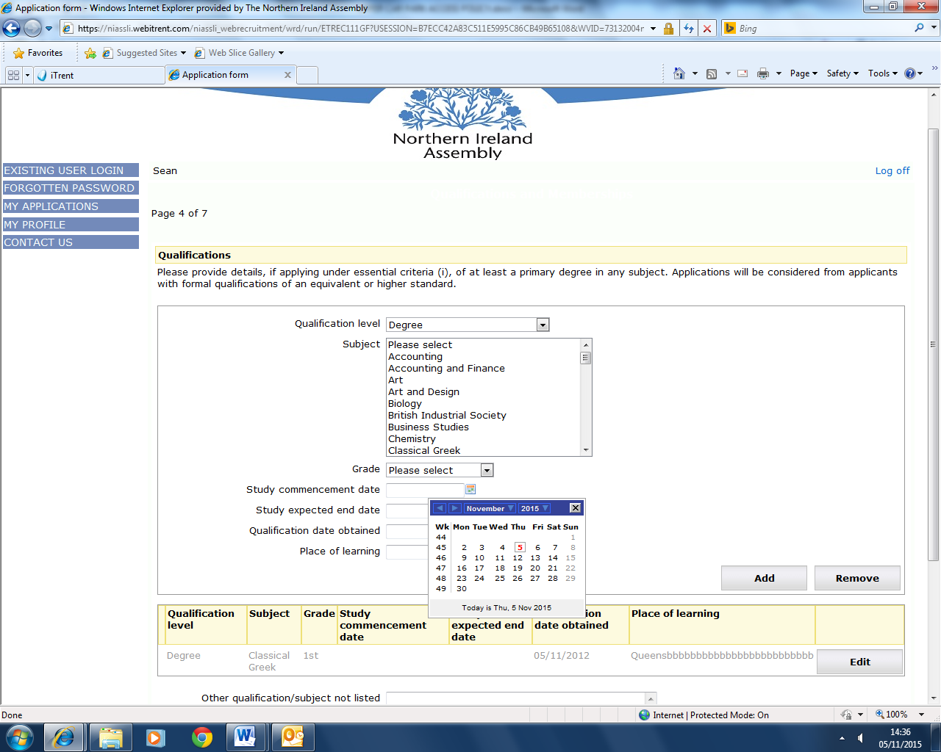
If you need to add any other qualifications use the ‘add’ button. If your qualification and/or subject is not listed in the drop down menu, please use the ‘other qualification/subject not listed’ text box. If you run out of characters when entering the information, you will need to abbreviate accordingly e.g. the name of the University you attended.

When completing the essential and/or shortlisting criteria boxes, you need to be aware that the system does not count down the number of characters remaining. On most internet browsers the system will automatically stop you from exceeding the character limit. However, this will not happen on Internet Explorer 8 or earlier versions. If you are using an earlier version of Internet Explorer, the message below will appear and the text boxes will be highlighted in red to indicate that the maximum data length has been exceeded. Please ensure that, when you have completed the essential criteria fields, you click the ‘save’ button as this will inform you if the maximum data length has been exceeded. Please note that this also applies to shortlisting criteria boxes if these are applicable to the application form.
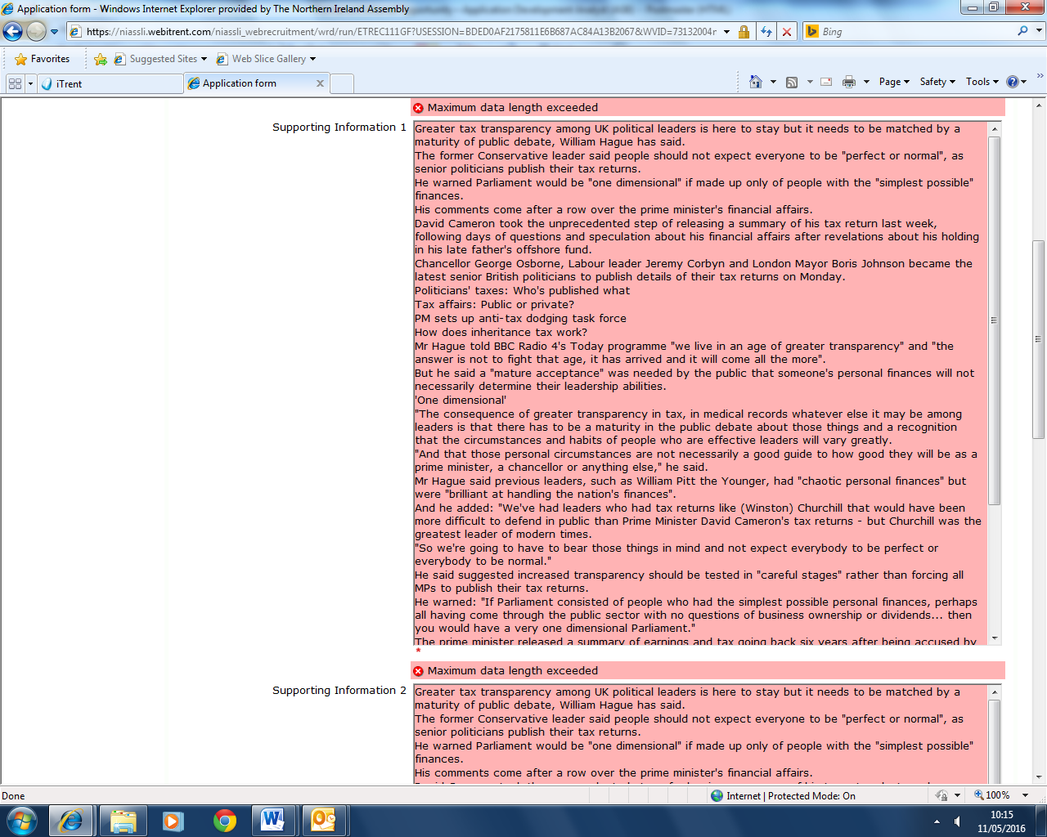

To save your information and progress, you will need to edit the character count to meet the stated limit. Please continue to use the ‘save’ button as you progress through the form or if you wish to exit out of the form and come back to it at a later time. You are advised to use Word to gauge your character count and further advised not to copy directly from Word to the iTrent application form as it is a HTML system and errors could occur with the text. It is better to copy text from Word to Notepad and then from Notepad into the application form.
The asterisk symbol denotes mandatory fields which must be completed as shown in the screen shot below. You will not be able to move to the next section of the form unless you populate at least one of the boxes with text.
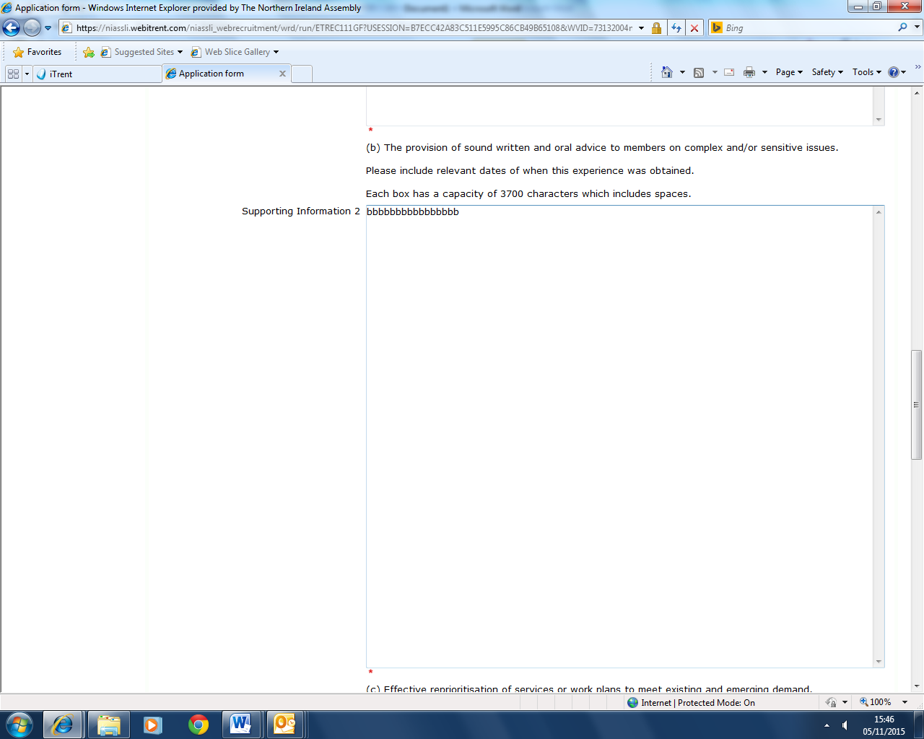

When all essential and/or shortlisting criteria boxes are complete, you will be asked to complete a declaration by placing a tick in the box as per screen shot below.
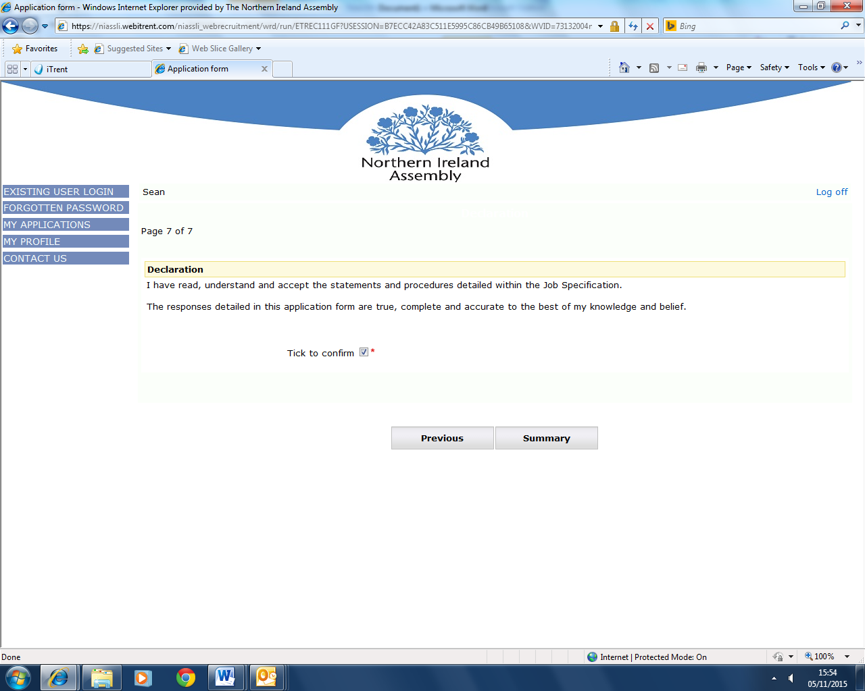

Once the declaration box has been ticked, you must hit the save button which will return you to the page that will allow you to submit your application.
You should then hit the ‘apply’ button at the top of the screen as indicated in the screen shot below.
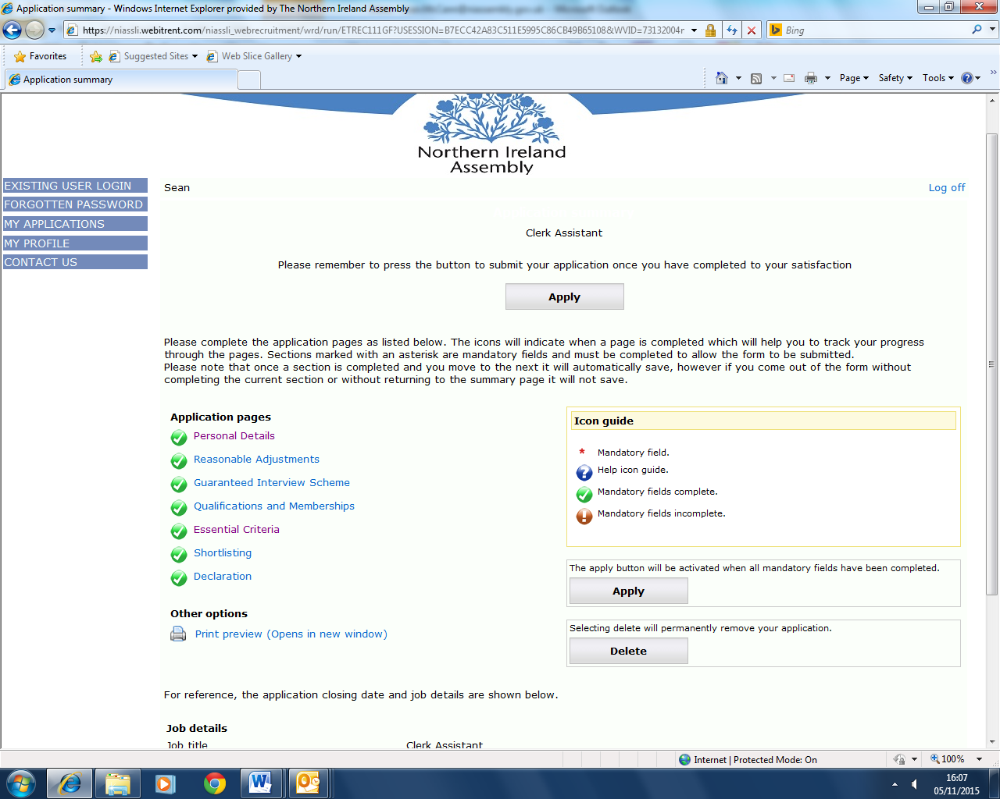

When the ‘apply’ button has been pressed, you will see the screen below asking if you wish to continue or cancel and return to the form. This is the final chance for you to amend your form and if you are content to proceed you should hit the ‘continue’ button.
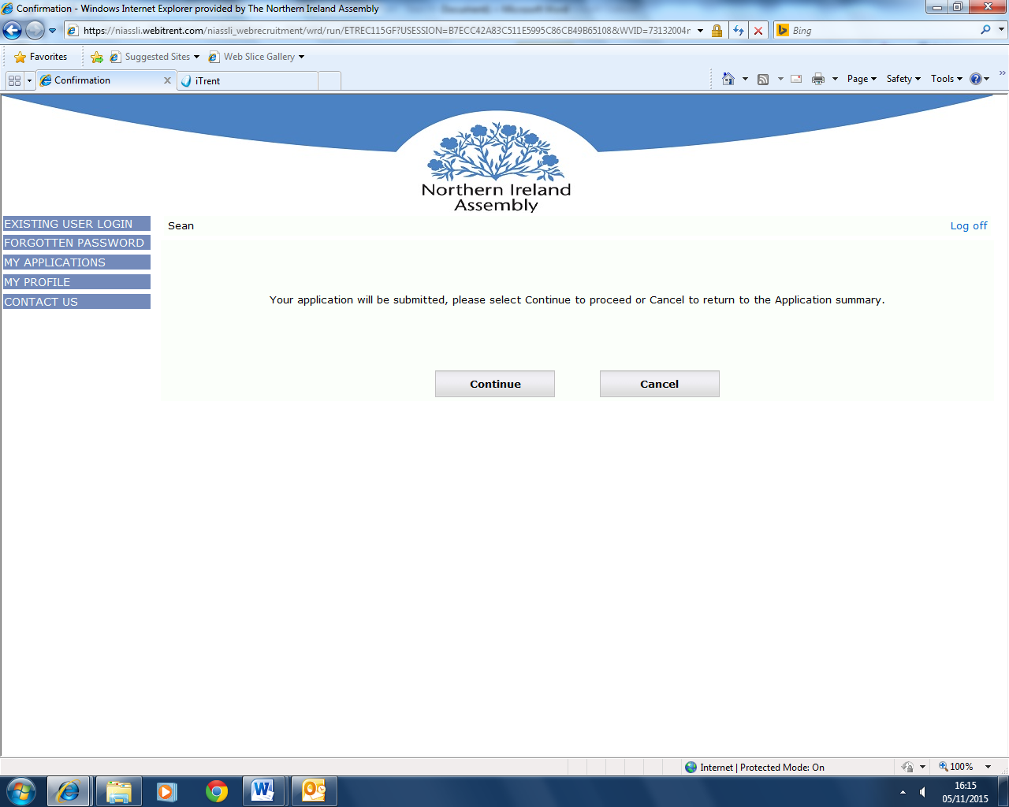
Once the ‘continue’ button has been pressed, you will receive a message to advise that your application has been submitted and you will also receive an e mail to this effect. If you do not receive this email, you should contact the HR Office as soon as possible.

