Paper 000/00 10 November 2015 NIAR 628-2015

John McCaul
Disciplinary procedures and the role of lay persons and professional members in selected non-legal professions

1 Introduction
This briefing paper has been written in response to a request from the Committee for Finance and Personnel regarding the arrangements within non-legal professions in terms of best practice relating to the role of lay persons and professional members of disciplinary or complaints committees. Professions examined in this briefing paper include accountancy, medicine and social care. This document also looks at how these arrangements compare to the provisions as proposed in the Legal Complaints and Regulation Bill (the Bill). Lastly, this paper concludes with a summary of key points and observations for the reader to consider.

2 List of Abbreviations
CAI- Chartered Accountants Ireland
CARB- Chartered Accountants Regulatory Board
CCW- Care Council for Wales
FTTP- Fitness to Practice Panel
GMC- General Medical Council
HCPC- Health and Care Professions Council
HPC- Head of Professional Conduct
IC- Investigating Committee
ICAEW- Institute of Chartered Accountants England and Wales
ICAS- Institute of Chartered Accountants Scotland
IOP- Interim Orders Panels
LSOC- Legal Services Oversight Commissioner
MPTS- Medical Practitioners Tribunal Service
NISCC- Northern Ireland Social Care Council
PCC- Professional Conduct Committee
PPC- Preliminary Proceedings Committee
SSSC- Scottish Social Services Council
UK- United Kingdom
3 Accountancy
With regard to the accountancy profession, this paper studies the role of lay persons and professionals in the disciplinary arrangements of one All-Ireland institution and two principal United Kingdom (UK) organisations- Chartered Accountants Ireland (CAI), Institute of Chartered Accountants Scotland (ICAS) and the Institute of Chartered Accountants England and Wales (ICAEW).
Chartered Accountants Ireland
Chartered Accountants Ireland is regulated by the Chartered Accountants Regulatory Board (CARB) ‘with the provisions of its Bye-laws, independently, openly and in the public interest.’ In total there are 12 board members, 5 accountants and 7 non-accountants. Figure 1 illustrates CARB’s disciplinary process bar the role of the new conduct committee. It is also worth noting that on Monday 5 October 2015 new Disciplinary Bye-Laws, new Disciplinary Regulations and amended Principal Bye-Laws came into operation. CARB notes that ‘all complaints and disciplinary matters will be handled in accordance with the new rules but it is the Disciplinary Bye-Laws which were in effect at the time the matter in question arose which will determine whether liability to disciplinary action arises.’

The Executive

CARB’s disciplinary regulations state that ‘each complaint shall be assessed by the Executive to determine whether it concerns a Disciplinary Matter.’ The term ‘Executive’ is also defined as ‘the staff of CARB who assist in carrying out the functions of CARB.’

CARB Investigator

If the complaint is identified as a disciplinary matter it is then scrutinised further by an investigator who ‘may be a member of the Executive and / or an employee of the Institute or a Member.’ For CARB, the Head of Professional Conduct (HPC) still retains ‘overall responsibility for the investigation.’ The current HPC is a barrister although there is no requirement in the disciplinary guidelines for a HPC to be either a layperson or professional. It is expected that a future HPC may be a chartered accountant.

Conduct Committee

If the complaint is not interpreted as a disciplinary matter and the complainant disagrees with this decision he/she can seek a decision from the conduct committee. This committee’s remit particularly concerns scrutiny ‘on more serious, higher-risk and complex cases.’ The conduct committee’s verdict is final if it considers that the complaint does not constitute a disciplinary matter. According to CARB disciplinary regulations, the ‘Conduct Committee appointed by the Board shall consist of no fewer than nine persons, of whom the majority shall not be accountants.’ Provision is also made for the board to appoint a chairperson and deputy chairperson. The regulations do not state whether the chairperson or deputy chairperson are required to be accountants or non-accountants.

Head of Professional Conduct and Independent Review Committee

Upon receipt of the investigator’s report, the HPC will determine whether the Member, Member Firm, Student or Affiliate has a case to answer. If the HPC determines that there is no case to answer the complaint will be considered by an Independent Review Committee drawn from the membership of the Appeal Panel. CARB guidelines state that ‘each Independent Review Committee shall consist of three persons one of whom must be an accountant and two of whom must not be accountants. The Convenor or Deputy Convenor [of the Appeal panel] shall appoint one member of the Independent Review Committee to act as chairperson.’ The Independent Review Committee reflects on previous decisions made by the conduct committee and the HPC and ‘disposes’ of complaints once its review process is complete.

Head of Professional Conduct and Disciplinary Tribunal

If the HPC asserts that there is a case to answer the HPC will either issue a consent order or refer the case to the Disciplinary Tribunal. Provision is made for the former option under regulation 27 in the CARB’s disciplinary regulations which is incorporated in the Appendix section of this paper. Regarding the latter, the Convenor or Deputy Convenor ‘appoint a Disciplinary Tribunal from the members of the Disciplinary Panel to hear each Formal Allegation referred by the Conduct Committee for hearing before a Disciplinary Tribunal and each application for an Interim Order.’
Further, regulation 10.3 states that ‘each Disciplinary Tribunal shall consist of three persons one of whom must be an accountant and two of whom must not be accountants. Each Disciplinary Tribunal shall include a lawyer as chairperson.’ Extra provision is also made for the disciplinary tribunal to appoint a practicing lawyer as a legal assessor. Regulation 43.1 permits the Member, Member Firm, Student or Affiliate to appeal the outcome of the disciplinary tribunal.

Appeal Tribunal

The Appeal Tribunal is the final stage of the disciplinary procedure. It draws its membership from the Appeal Panel which is composed ‘of no fewer than nine persons.’ CARB regulations state ‘each Appeal Tribunal shall consist of three persons one of whom must be an accountant and two of whom must not be accountants. Each Appeal Tribunal shall include a lawyer as chairperson.’ Like the Disciplinary Tribunal, the ‘Appeal Tribunal may appoint a Practising Lawyer to act as legal assessor.’

Figure 1: CARB’s complaints procedure
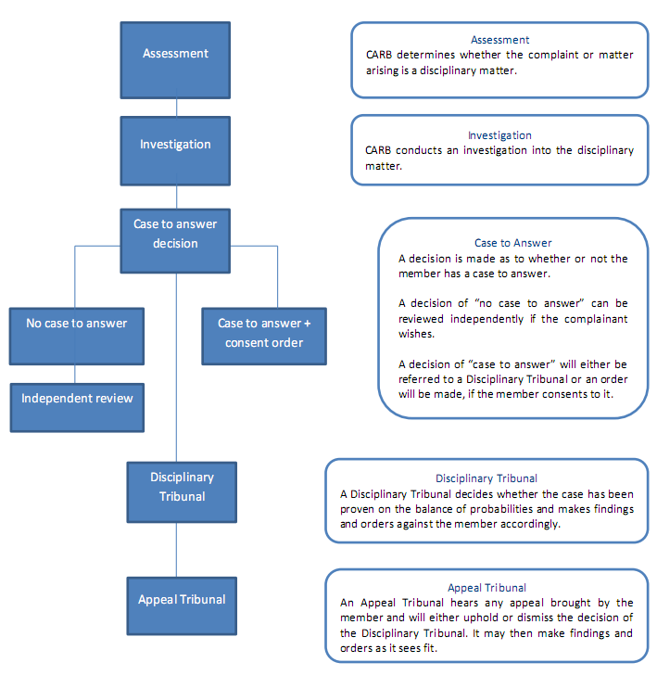

Institute of Chartered Accountants Scotland (ICAS)
ICAS is responsible for regulating Chartered Accountant members, student members, affiliates and firms in Scotland.
ICAS caseworker
Once a complaint is made it is assigned to an accountant or solicitor who is also employed as an ICAS caseworker and if there are ‘grounds for further investigation’ it is referred to the ICAS Investigation Committee.
Investigation Committee
ICAS guidelines describe the Investigation Committee as ‘comprised of a Convener and twelve or more other persons. Not less than one half of the Committee shall comprise Public Interest Members.’ Further, the Committee’s convenor is empowered to appoint an Investigator, usually the Case Officer, to ‘conduct detailed enquiries’. The convenor is a chartered accountant and the deputy convenor is a PIM.
Adjudication Committee
After the complaint passes through the Investigation Committee stage the ICAS regulations state that ‘in most cases’ the complaint is referred to the Adjudication Committee. This is composed of three or more members drawn from the Investigation Committee. Its membership includes ‘at least one Chartered Accountant and one Public Interest Member.’ Like the Investigation Committee, the convenor and deputy convenor are a chartered accountant and PIM respectively.
The Adjudication Committee may decide to dismiss a complaint. In this case the complainant has the option for the matter to be reviewed by a qualified solicitor known as the ‘Independent Examiner.’ The Adjudication Committee may also uphold the complaint. In this scenario, sanctions may be applied, appealed against or referred to the Discipline Panel.

Discipline Panel

The Discipline Panel is also established by the Discipline Board and its membership includes ‘no fewer than six Members of ICAS, no fewer than six Public Interest Members and no few than four legally qualified persons.’ Like the Appeal panel, the Discipline Board also appoints a legally qualified person to the chairperson role. The quorum’s makeup is also identical.

Discipline Tribunal

Further, it is from this panel that a Discipline Tribunal obtains its members which include, at least, the following: ‘a legally qualified member as Chairman, not fewer than one Member of ICAS and not fewer than one Public Interest Member of the Panel.’ Under ICAS regulations a discipline tribunal may also be heard ‘in the absence of any one member of a discipline Tribunal except the Chairman, provided that if the defender is present, the hearing may proceed in the absence of such member only if the defender consents.’

Appeal Panel

Created by the Discipline Board, the Appeal Panel is ‘comprised of no fewer than two Members of ICAS, no fewer than two Public Interest Members and no fewer than two legally qualified persons.’ One of these legally qualified persons is also appointed as chair of the panel by the Discipline Board. The panel must also have at least one ICAS member, one PIM and one legally qualified member present at a hearing for a quorum to be achieved.

Appeal Tribunal

It is from the Appeal Panel’s membership that an Appeal Tribunal is drawn. A tribunal comprises a legally qualified person as Chairman, a Member of ICAS and a PIM. ICAS regulations also state that ‘an appeal may be heard in the absence of any one member of an Appeal Tribunal other than the Chairman, provided that if the appellant is present the appeal may be heard in the absence of such member only if the appellant consents.’

Institute of Chartered Accountants England and Wales (ICAEW)
The ICAEW regulates members, member firms, students and affiliates in England and Wales.
Figure 2: The ICAEW’s complaints handling process (source: http://www.icaew.com/~/media/corporate/files/about%20icaew/what%20we%20do/protecting%20the%20public/complaints%20process/how%20we%20investigate%20complaints%20booklet.ashx)
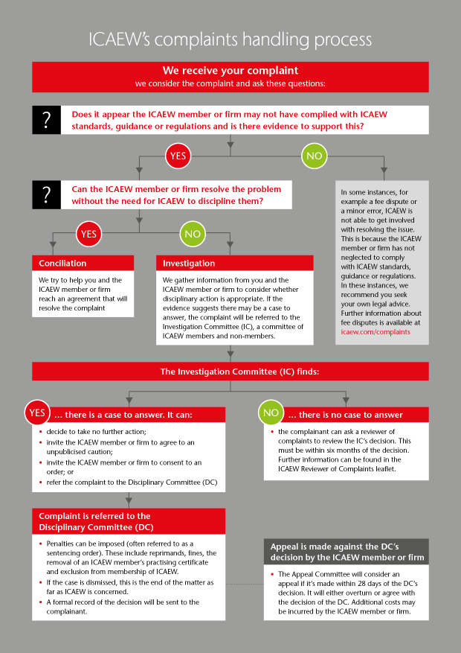

Investigation Committee
Where the ICAEW member or firm cannot reach a solution with the complainant by conciliation the ICAEW will refer the matter to the Investigation Committee in order to determine whether the member or firm has a case to answer. According to the ICAEW, this committee ‘consists of at least 14 people of whom at least 25% are not chartered accountants.’ The chair of the IC can be a lay person or an accountancy professional.
Disciplinary Committee
Where the Investigation Committee believes that an ICAEW member or firm has a case to offer it can refer the complaint to the Disciplinary Committee.
This committee is composed of three people- two chartered accountants and one layperson. Currently, there is no requirement for the chairperson to be an accountancy professional or a layperson. However, this will change from 2016.
The case is presented to the committee by an ICAEW member of staff or barrister and a legal assessor (an independent solicitor or barrister) ‘advises the tribunal on law and procedure but isn’t involved in taking decisions.’
Appeal Committee
The ICAEW clearly state that the Appeal Committee is comprised of ‘panels of five people: three chartered accountants, one non-accountant and a legally qualified chairman.’ According to an ICAEW committee secretary, ‘the chairperson of the Appeal Committee has to be a senior barrister and/or QC.’
3 Medicine
The two organisations which regulate the medical profession in the UK and the Republic of Ireland are the General Medical Council and the Medical Council, respectively.
General Medical Council (GMC)
As part of its complaints procedure the GMC has case examiners and establishes an interim orders panel and a fitness to practice panel.

Case Examiners
Case examiners (two senior GMC staff members) act at the investigation stage of a complaint to consider the case once information (for example, medical records, written complaint, doctor’s response and so on) has been received from both the complainant and the doctor. One of the case examiners is a doctor and the other is a layperson.
The case examiners will contemplate whether ‘the concerns are serious enough for the doctor to attend a hearing.’ Where there are grounds for a hearing the case examiners will refer the complaint to a Fitness to Practice Panel (FTPP) of the Medical Practitioners Tribunal Service (MPTS).
Fitness to Practice Panel
According to the MPTS, the FTPP inquires ‘into allegations of impaired fitness to practise.’ Panellists are recruited openly by the MPTS and suitability is determined in relation to a list of agreed competencies. The MPTS states that the pool panellists are drawn from contains almost 300 individuals although FTPP cases are heard by a smaller figure- at least three people. These personnel include the Chair, one medical and one non-medical panellist. It is possible for the Chair to be either medical or non-medical. The panellists are also joined by a legal assessor who ‘advises on points of law and of mixed law and fact, including the procedure and powers of the panel.’ However, the attendance of one or more specialist advisers is not compulsory. These advisers ‘provide advice to the panel in relation to medical issues regarding a doctor’s health or performance.’
Appeals
Where the FTPP has adjudged that the doctor’s registration be restricted or removed, he/she can appeal the decision via the High Court (Court of Session in Scotland).The MPTS notes that the ‘Council for Healthcare Regulatory Excellence may also appeal against certain decisions if they consider the decision was too lenient and does not protect the public.’
Interim Orders Panels
At any stage in the investigation process a complaint may be referred to an interim orders panel of the MPTS. These panels are empowered to ‘suspend or impose conditions on the doctor’s registration while the investigation continues.’ Like the FTPP, three individuals usually sit on an IOP, including the Chair, one medical and one non-medical panellist. The Chair may be either medical or non-medical.
Medical Council (Republic of Ireland)
Like its UK counterpart, the Medical Council in the Republic of Ireland makes provision for case examination, a Preliminary Proceedings Committee (PPC) and a Fitness to Practice Committee. The Council has 24 members- twelve are Medical including the president and vice-president and twelve are non-medical. The Medical Council also has a Nominations & Development Committee ‘which advises Council on the nomination process for appointments to committees and also advises on the provision of induction, training and development for members.’
Case Examiner
A case examiner, a non-medical individual, is assigned by the Medical Council to assist the PPC in its investigation of a complaint. This is pursuant to section 58(1) (a) of the Medical Practitioners Act 2007 as amended (“the Act”). Section 58 (1) (a) states that the Council is empowered to ‘appoint persons (including any members of the staff of the Council other than the chief executive officer) to assist the Preliminary Proceedings Committee.’
PPC
The PPC investigates the compliant fully and provides an opinion to the Medical Council. However, it is the Council’s responsibility to determine the appropriate action which is final. This may include referral to the Fitness to Practice Committee. Currently, the PPC is comprised of a pool of 16 panellists, six are council members including the Chair and ten are external appointments. Of the six council members, three are lay persons and three are medical professionals and regarding the ten external appointments, only one is a lay person and nine are medical professionals. Therefore, on the PPC there are 12 medical professionals and four lay persons.
Fitness to Practice Committee
The Fitness to Practice Committee is normally comprised of three people: two non-medical and one medical.’ There is no requirement for the chairperson to be either a medical professional or a layperson but he/she must be a council member. A Legal Assessor also sits with the Committee and ‘advises and informs the Committee and the other people involved about the law and procedure.’ He/she does not make decisions. Upon completion of the hearing, the Committee will give its findings and compile a report citing its conclusions and reasons for them. This report is then sent to the Council. Where the Committee reports that the allegations have been proved against the doctor the Council will impose sanctions.
Appeals Process
If sanctions from the Medical Council include imposition of a fine, suspension, expulsion or changes to a doctor’s registration, he/she has a right of appeal to the High Court. The Medical Council notes that ‘if no appeal is made against the Medical Council's decision, the Medical Council will apply to the High Court to confirm its decision.’
4 Social Work
Northern Ireland Social Care Council (NISCC)
The NISSC regulates the social care profession in Northern Ireland. The NISCC makes provision for a Conduct Team a Preliminary Proceedings Committee (PPC), a Conduct Committee and an Appeal Tribunal in its conduct rules. Members of the PPC and the Conduct Committee are drawn from a pool of 42 individuals having previously been recruited. They serve for at least one four year term. This group is split equally between social care professionals and lay persons.
Conduct officer
Once the NISCC receives a complaint it is passed to a case owner (also one of the five conduct officers within the Conduct Team) who is assigned to it until the case has been disposed. There is no requirement for a conduct team post holder to be either a social care professional or a layperson but he/she must ‘have a third level qualification (or five years’ relevant experience) in social work, human resources or law, with formal investigative experience.’
PPC and the Conduct Committee
The PPC and the Conduct Committee are both comprised of at least three members, including one layperson, one social care professional and one lay chairperson. Depending on the seriousness of the case, the memberships of the PPC and the Conduct Committee may increase to five.
Care Tribunal
The NISSC’s disciplinary process also permits registrants to ‘appeal to the Care Tribunal against any decision made by a Committee.’ However, the tribunal is not facilitated by the NISSC as it comes under the remit of the Northern Ireland Courts and Tribunals Service.
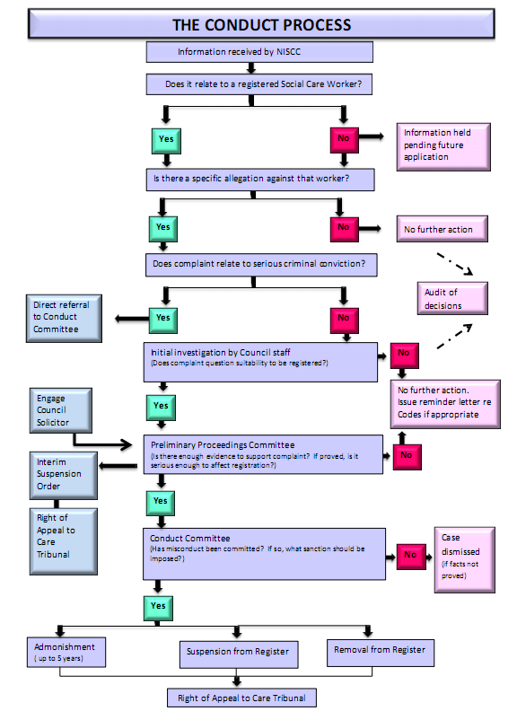
Figure 3: NISCC conduct process (source: http://www.niscc.info/files/Conduct/2014_Picture_Guide_Conduct.pdf)

Scottish Social Services Council (SSSC)
The SSSC is responsible for regulating the social care profession in Scotland.
Caseholder
The SSSC initiates its investigation process by assigning a caseholder to a complaint. Under the SSSC’s conduct rules, the caseholder is empowered to take no further action, impose a sanction or refer the case to a sub-committee (for example, the Preliminary Proceedings sub-committee and the conduct sub-committee). The sub-committees are drawn from the membership of the Conduct Committee.
Conduct Committee
The Conduct Committee, a regulatory committee, is established by the SSSC. Moreover, it reports ‘to the Council on outcomes and disposals of the Preliminary Proceedings Sub-committees and Conduct Sub-committees as well as advising them of any training required for those Committees and Sub-committee members.’ The Conduct Committee consists of a pool of 60 people with an exact split between social care professionals and lay persons. This cohort is recruited via announcement notices on the SSSC website and advertisements in Scottish publications. A recruitment process is ongoing currently. The Convenor of the Committee is drawn from the Council which is Scottish Government-appointed. Under SSC conduct rules, ‘members of the Committee shall be appointed for a period not exceeding 3 years and shall be eligible for re-appointment for further periods not exceeding 4 years in total.’
Preliminary Proceedings sub-committee and Conduct sub-committee
The Preliminary Proceedings sub-committee is concerned with considering applications for and imposing Interim Suspension Orders and/or Interim Conditions Orders. The Conduct sub-committee’s remit relates to deciding whether the registrant has committed misconduct, the appropriate sanction if misconduct has been proved, whether the registrant should have conditions placed on their registration and applications regarding restoration to the register. According to the SSSC’s conduct rules both the Preliminary Proceedings sub-committee and the Conduct sub-committee are comprised ‘from the pool of persons appointed by the Council to the Conduct Committee.’ The maximum number of members on a committee is five while two is necessary for a quorum. The conduct rules also state that ‘each Sub-committee shall consist of at least one Lay Person and one Due Regard member.’ Further, the SSSC appoints a Convenor of each sub-committee (drawn from the Conduct Committee) who must be a layperson. Both these sub-committees are assisted by a Legal Advisor and a Clerk. Finally, Conduct Rules note that ‘decisions of the Sub-committees shall be treated as those of the Council.’
Appeal process
A registrant has the right to appeal a decision by the SSSC although this process is facilitated through the Scottish courts system and not by the agency.
Care Council for Wales
The Care Council for Wales (hereafter, the Care Council) is the regulatory body for the social care profession in Wales. The Care Council’s disciplinary process begins with the complaint being passed to an Internal Case Conference for an initial risk assessment.

Internal Case Conference

This comprises Care Council’s staff members including the Director of Regulation and Professional Standards, the Conduct Investigations Manager and the Conduct Investigations Officers. These individuals are empowered to recommend to the Investigations Committee that an Interim Order be imposed on the registrant, to close the case to impose an undertaking and refer the matter to the Investigating Committee (IC). After considering the evidence further the IC may refer the case to the Conduct Committee.

Investigating Committee and the Conduct Committee

In accordance with the Care Council’s Rules, both the IC and the Conduct Committee are comprised of three members, two lay members (one is the committee chairperson) and one social care professional (registered with Care Council or eligible to be registered). These individuals are recruited through public competition and appointed by the Care Council. Recruitment methods include advertisements on Care Council’s website and in local and national Welsh newspapers.

Appeal process
A registrant has the right to appeal a decision by the Care Council although this process is facilitated through Her Majesty’s Courts and Tribunal Service and not the agency. The group established to hear appeals against Care Council decision is the First Tier (Care Standards) Tribunal.
Health and Care Professions Council (England)

The Health and Care Professions Council (HCPC) is a regulatory agency for England which oversees the social care profession and others including clinical scientists, paramedics and radiographers.

The HCPC’s committees are formed from a large pool of both social care professionals and lay persons who are recruited via two separate processes. Lay persons are recruited through advertisements in the Guardian while social care professionals are acquired via advertisements placed on the HCPC website, in the HCPC publication, In focus, and in social care-related journals. Applicants must submit application forms and attend an interview. HCPC currently has a pool of 230 panel members- 46 are lay persons and 184 are social care professionals. Further, the HCPC has a separate recruitment pool for chairpersons. In total, there are 35 chairpersons- one is a social care professional and the remainder are lay persons.

Case manager

The HCPC complaints process commences with the case being referred to a case manager in the Fitness to Practise Department. The case manager determines whether a case meets the HCPC’s Standards of Acceptance and it is passed to the HCPC. There is no requirement for the case manager to be a social care professional or lay person. After a further investigation by the HCPC the case is referred to the Investigating Committee.
Investigating Committee (IC)

The IC is comprised of ‘at least three people, including someone from the relevant profession and a ‘lay’ person who is not from any of the professions we regulate.’ Like the case manager, it is not compulsory for the chairperson to be either a social care professional or lay person. The registrant has recourse to a judicial review if that individual believes that the HCPC has not followed ‘its process correctly.’

Where the IC adjudges there is ‘a case to answer’, the matter, if it relates to alleged misconduct or incompetence, will be referred to the Conduct and Competence Committee. Where the case relates to concerns about the registrant’s health it will be referred to the Health Committee.

Conduct and Competence Committee and Health Committee

Both the Conduct and Competence Committee and Health Committee consist of a registrant from the same profession as the person being investigated, a lay person who is not registered with the HCPC and a chairperson (who may be a lay person or from a HCPC-regulated profession) who leads the hearing and speaks for the panel. In addition to the registrant and his/her legal representative, there is a Legal Assessor, a hearings officer, a transcriber and a HCPC official in attendance.

Appeals process

The HCPC does not oversee an appeal process but a registrant is permitted to appeal to the High Court in England and Wales or Northern Ireland, or the Court of Session in Scotland.

The Professional Standards Authority for Health and Social Care is responsible for reviewing ‘all final decisions made by the regulators’ fitness to practise committees.’ It is empowered to refer decisions to the High Court in England, Wales, or Northern Ireland or the Court of Session in Scotland ‘if it considers that they are unduly lenient and do not protect the public.’

CORU (Republic of Ireland)
In the Republic of Ireland the social care profession is regulated by CORU. CORU covers the Health and Social Care Professionals Council and the Registration Boards established under the Health and Social Care Professionals Act 2005 (as amended).

The first stage in CORU’s complaints process is referral to its Preliminary Proceedings Committee (PPC).

Preliminary Proceedings Committee

The PPC is comprised of seven people including three lay persons, two registrants of the same profession as the registrant being complained about and two registrants from a different profession. Where the PPC is content that the complaint warrants further action, and mediation is unsuitable, it will be referred for a Committee of Inquiry (Professional Conduct Committee or Health Committee).

Professional Conduct Committee (PCC) and Health Committee

The PCC is concerned with complaints regarding a registrant’s conduct or competence while the Health Committee decides if a registrant’s relevant medical disability is impacting his/her professional work.

Both committees are composed of three people: one layperson, one registrant from the same profession as the registrant being complained about and one registrant from a different profession. A legal assessor is present at both committees while a registered medical practitioner only attends the Health Committee. These committees adjudge whether the case against the registrant has been proven. Sanctions are decided upon by the CORU council and imposed by the Registration Board.

Appeals process

CORU does not facilitate an appeals process but a registrant can make an appeal to the High Court in the Republic of Ireland’s Courts Service.
5 Comparison with provisions proposed in the Legal Complaints and Regulation Bill
This review of the role of lay persons and professionals within the complaints handling and disciplinary process of the accountancy, medicine and social care professions in Northern Ireland, Great Britain and the Republic of Ireland has provided several points of comparison with complaints procedures for both barristers and solicitors in the Legal Complaints and Regulation Bill (the Bill). Given time constraints this report has looked at a selected number of bodies within the accountancy, medical and social care professions in relation to the role of lay persons and professionals on disciplinary committees.
Several key take-away points for readers to consider include:
- Overall, this report concludes that no clear relationship has been uncovered between the stage in the disciplinary process and committee/panel balance in terms of lay persons and professional membership.
However, it is worth noting a study conducted in 2013 by the Royal College of Veterinary Surgeons, which scrutinised the UK’s nine health and care professional regulators (covering thirty-one regulated professions), two of the eight legal services regulators and four international regulators of veterinary surgeons. This paper surmised that regulators have ‘accepted and even embraced sharing responsibility for regulation between professionals and the public, with parity of lay people and registrants on governing boards.’ This finding is significant given that the authors’ main focus was determining best practice among regulators in the UK and beyond.
- The Bill’s provision, in relation to the Bar Complaints Committee and the Solicitor Complaints Committee, for lay persons to comprise a majority of committee members and for the chair to be a lay person matches a growing trend within regulatory agencies in other professions. For example, the membership of CARB’s and the Care Council’s (for Wales) complaints committees have a majority of lay persons. Further, the ICAEW’s disciplinary committee has introduced a requirement whereby its disciplinary committee chair must be a layperson starting in 2016.
However, several agencies scrutinised in this paper such as ICAS, the GMC and the NISCC maintain parity between the numbers of lay persons and professionals on committee panels and in recruitment pools.
- The Medical Council in the Republic of Ireland is an interesting case as its PPC (16 seats) has an overwhelming majority of medical professional members (12) compared to the quantity of lay persons (4). However, at the Fitness to Practice Committee stage there are two lay persons and one medical professional on the panel. Moreover, the common composition of disciplinary and conduct panels, as exemplified by the GMC and HCPC, is one professional and one layperson panellist in addition to a chair.
- The timescale of the term of office for members of both committees (‘not… more than 5 years at a time’) is similar to those specified by other regulatory agencies including the NISCC (4 years) and the SSSC. The SSSC case is more complex as its conduct rules state that ‘members of the Committee shall be appointed for a period not exceeding 3 years and shall be eligible for re-appointment for further periods not exceeding 4 years in total.’ CARB does not have a fixed term limit although one-third of its board members retire at each Annual Appointing Meeting. A term limit for panellists on the MPTS is not mentioned in its core founding legislation, General Medical Council (Constitution of Panels and Investigation Committee) Rules Order of Council 2004.
- This paper demonstrates that the role of lay persons/regulator employees in complaints procedures is not discernible in committees solely. It is also noticeable in other areas of the process including the case holder/case examiner/investigator stage (see especially the social care regulators). For example, CARB’s Head of Professional Conduct is currently a barrister who ‘retains overall responsibility for the investigation’ and determines whether or not the respondent has a case to answer.

Points not relating to the role of lay persons and professionals in conduct and disciplinary committees but important observations made by the author are included here:
The Bill does not make provision for the position of a ‘deputy chairperson’ or ‘acting chairperson’ where the chairperson is unfit to participate in proceedings. Regulatory agencies analysed in this paper, mostly in the accountancy profession, provided for this role within their disciplinary regulations.
Both the SSSC’s and CORU’s complaints procedures permit one ‘due regard’ representative to sit on their respective conduct committees. It may be worth pondering whether a ‘due regard’ position should be added to the membership of the Bar Complaints Committee and the Solicitor Complaints Committee. Similarly, it should be considered whether a lay person may be named a ‘Public Interest Member’, a practice that is followed by ICAS.
The Bill compels the Benchers of the Honourable Society of the Inn of Court and the Law Society to consult initially with the Legal Services Oversight Commissioner (LSOC) regarding the manner of appointments to the Bar Complaints Committee and the Solicitors Complaints Committee. Regulatory agencies analysed in this study do not have the same obligation to report to an overseeing body. It is worth considering whether this strong level of oversight is necessary.
The Bill’s prohibiting of General Council of the Bar members and Law Society Council members from serving on the Bar Complaints Committee and the Solicitor Complaints Committee respectively, is mirrored in other regulatory agencies such as the GMC and SSC which recruit committee members externally. In this paper, the Republic of Ireland’s Medical Council is the only regulator which permits its council members to participate in complaints and disciplinary committees.
It is worth highlighting that Clauses 25 and 44 of the Bill enable both committees to report publicly on the investigation although the respondent’s name or any identifying particulars cannot be revealed without his/her consent. This is in contrast to the procedure of regulators in this paper such as the GMC (via MPTS), CARB and the SSSC who publish notifications of hearings on their website and publish reports which identify the respondent. According to the conduct rules of CARB, the GMC and the SSSC, there is nothing in legislation to prevent these regulators identifying respondents in reports or online notifications of hearings.

Clauses 11 and 29 of the Bill empower both the General Council of the Bar and the Law Society to compel ‘every barrister’ and ‘every solicitor’ to establish and maintain their own complaints procedure. This echoes the procedure in the accountancy and social care professions where complaints are not investigated by regulators unless the complainant provides evidence of attempting to resolve the matter with the individual/firm/affiliate/student.

The provision within the Bill for both committees to establish sub-committees compares strongly with the Preliminary Proceedings and Conduct sub-committees in the SSSC conduct procedure. These sub-committees are established by the SSSC and report their findings to the Conduct Committee. However, this facility is not employed by other regulatory agencies analysed in this paper. Rather than establish sub-committees, they employ case examiners, an investigation committee and a main disciplinary/conduct committee. Medical profession-based regulators also utilise interim orders panels.

Finally, the Bill makes provision for complainants and respondents to appeal against decisions by the two committees to the High Court of Northern Ireland. All regulators scrutinised in this report permit the complainant or respondent to appeal. In the case of ICAEW and CARB the appeal process is facilitated in-house while in others, complainants or respondents engage with the High Court (England, Wales, Northern Ireland and Republic of Ireland) or the Court of Session (Scotland).

Appendix A

27 Consent Orders

27.1 The Head of Professional Conduct or the Conduct Committee may, with the agreement of the Member, Member Firm, Student or Affiliate concerned, make any one or more of the orders which a Disciplinary Tribunal would have power to make in respect of a Member, Member Firm, Student or Affiliate including an order that the Member, Member Firm, Student or Affiliate concerned shall pay to the Institute a specified sum by way of costs.
27.2 Any such order may be made upon such terms and conditions (if any) as the Head of Professional Conduct or the Conduct Committee considers appropriate.
23

27.3 Before a Consent Order is made, the Member, Member Firm, Student or Affiliate concerned shall be issued with a notice:

27.3.1 describing the action which the Head of Professional Conduct or the Conduct Committee proposes to take if the Member, Member Firm, Student or Affiliate agrees; and
27.3.2 specifying the order which he, she or it would make in that event.

27.4 If the Member, Member Firm, Student or Affiliate concerned agrees in writing to proceeding as proposed in the notice, the Head of Professional Conduct or the Conduct Committee shall make the order specified in the notice unless, having regard to any further information, which he, she or it has received (prior to the making of such order) whether from the Member, Member Firm, Student or Affiliate concerned, or any other source whatever, he, she or it is of the opinion:

27.4.1 that a lesser or no penalty is appropriate, in which case he, she or it shall impose a lesser or no penalty, as the case may be;
27.4.2 that a smaller or no sum is appropriate by way of costs, in which case he, she or it shall order a smaller sum to be paid by way of costs or make no order as to costs, as the case may be;
27.4.3 that there is no case to answer in respect of the Disciplinary Matter, in which case he, she or it shall so find; or
27.4.4 that a greater penalty or a referral for hearing before a Disciplinary Tribunal is appropriate, in which case he, she or it shall serve on the Member, Member Firm, Student or Affiliate concerned a supplemental notice identifying the further information and indicating the extent of such greater penalty or other action as the Conduct Committee or the Head of Professional Conduct considers appropriate.

27.5 If the Member, Member Firm, Student or Affiliate does not agree in writing to proceed as proposed in the notice, the matter shall be referred for hearing before a Disciplinary Tribunal by the Head of Professional Conduct directly.

(Source: Chartered Accountants Regulatory Board, ‘Disciplinary Regulations’, retrieved 27 October 2015 http://www.carb.ie/Documents/Support%20and%20Guidance/Insolvencysandg/FINAL%20Disciplinary%20Regulations%20051015.pdf, pp 22-23.)

Chartered Accountants Regulatory Board, ‘Guide to making a complaint and to CARB’s Disciplinary Process’, retrieved 28 October 2015 http://www.carb.ie/Documents/Rules%20and%20Regulations/Disciplinary/Draft%20Guide%20to%20the%20Disciplinary%20Process.pdf
Chartered Accountants Regulatory Board, ‘New Disciplinary Bye-Laws’, retrieved 27 October 2015 http://www.carb.ie/en/Public-Information/News/News-2015/New-Disciplinary-Bye-Laws/
Chartered Accountants Regulatory Board, ‘Disciplinary Regulations’, retrieved 27 October 2015 http://www.carb.ie/Documents/Support%20and%20Guidance/Insolvencysandg/FINAL%20Disciplinary%20Regulations%20051015.pdf, p. 2.
Chartered Accountants Regulatory Board, ‘Disciplinary Regulations’, retrieved 27 October 2015 http://www.carb.ie/Documents/Support%20and%20Guidance/Insolvencysandg/FINAL%20Disciplinary%20Regulations%20051015.pdf, p. 13.
Chartered Accountants Regulatory Board, ‘Disciplinary Regulations’, retrieved 27 October 2015 http://www.carb.ie/Documents/Support%20and%20Guidance/Insolvencysandg/FINAL%20Disciplinary%20Regulations%20051015.pdf, p. 13.
Chartered Accountants Regulatory Board, ‘Disciplinary Regulations’, retrieved 27 October 2015 http://www.carb.ie/Documents/Support%20and%20Guidance/Insolvencysandg/FINAL%20Disciplinary%20Regulations%20051015.pdf, p. 6.
Chartered Accountants Regulatory Board, ‘Disciplinary Regulations’, retrieved 27 October 2015 http://www.carb.ie/Documents/Support%20and%20Guidance/Insolvencysandg/FINAL%20Disciplinary%20Regulations%20051015.pdf, p. 9.
Chartered Accountants Regulatory Board, ‘Disciplinary Regulations’, retrieved 27 October 2015 http://www.carb.ie/Documents/Support%20and%20Guidance/Insolvencysandg/FINAL%20Disciplinary%20Regulations%20051015.pdf, p. 8.
Chartered Accountants Regulatory Board, ‘Disciplinary Regulations’, retrieved 27 October 2015 http://www.carb.ie/Documents/Support%20and%20Guidance/Insolvencysandg/FINAL%20Disciplinary%20Regulations%20051015.pdf, p. 8.
Chartered Accountants Regulatory Board, ‘Disciplinary Regulations’, retrieved 27 October 2015 http://www.carb.ie/Documents/Support%20and%20Guidance/Insolvencysandg/FINAL%20Disciplinary%20Regulations%20051015.pdf, p. 9.
Chartered Accountants Regulatory Board, ‘Guide to making a complaint and to CARB’s Disciplinary Process’, retrieved 28 October 2015 http://www.carb.ie/Documents/Rules%20and%20Regulations/Disciplinary/Draft%20Guide%20to%20the%20Disciplinary%20Process.pdf
Institute of Chartered Accountants Scotland (ICAS), ‘The Complaints Process: Guidance for Complainers’, retrieved 28 October 2015 https://www.icas.com/__data/assets/pdf_file/0010/2116/Helpsheet-General-Complaints-complainers.pdf
ICAS, Investigation Regulations, p. 2.
ICAS, Sanctions Guidance, p. 6.
ICAS, Discipline and Appeals Tribunals Regulations, p. 2.
ICAS, Discipline and Appeals Tribunals Regulations, p. 2.
ICAS, Discipline and Appeals Tribunals Regulations, p. 2.
ICAS, Discipline and Appeals Tribunals Regulations, p. 2.
ICAEW ‘Members - FAQs on ICAEW’s disciplinary process’, retrieved 28 October 2015 http://www.icaew.com/en/about-icaew/what-we-do/act-in-the-public-interest/complaints-process/faqs-on-the-disciplinary-process-for-members
Correspondence from ICAEW official on 4 November 2015.
ICAEW ‘Members - FAQs on ICAEW’s disciplinary process’, retrieved 28 October 2015 http://www.icaew.com/en/about-icaew/what-we-do/act-in-the-public-interest/complaints-process/faqs-on-the-disciplinary-process-for-members
ICAEW ‘Members - FAQs on ICAEW’s disciplinary process’, retrieved 28 October 2015 http://www.icaew.com/en/about-icaew/what-we-do/act-in-the-public-interest/complaints-process/faqs-on-the-disciplinary-process-for-members
Correspondence from ICAEW official on 4 November 2015.
GMC, ‘Investigating concerns’, retrieved 29 October 2015 http://www.gmcuk.org/concerns/the_investigation_process/investigating_concerns.asp
MPTS, ‘Information about panellists and legal assessors’, retrieved 29 October 2015 http://www.mpts-uk.org/about/1526.asp
MPTS , ‘Appeals’, retrieved 30 October 2015 http://www.mpts-uk.org/decisions/1656.asp
MPTS, ‘Interim Orders Panel, retrieved 30 October 2015 http://www.mpts-uk.org/hearing/interim_order_panel_referrals.asp
Medical Practitioners Act (Republic of Ireland) 2007 section 58 (1) (a).
Medical Council, ‘Preliminary Proceedings Committee’, retrieved 28 October 2015 http://www.medicalcouncil.ie/About-Us/Medical-Council-Committees/Preliminary-Proceedings-Committee.html
Medical Council, ‘Fitness to Practise Inquiries’, retrieved 29 October 2015 https://www.medicalcouncil.ie/Public-Information/Making-a-Complaint-/Fitness-to-Practise-Inquiries/
Medical Council, http://www.medicalcouncil.ie/About-Us/Medical-Council-Committees/Preliminary-Proceedings-Committee.html Medical Council, ‘Fitness to Practise Inquiries’, retrieved 29 October 2015 https://www.medicalcouncil.ie/Public-Information/Making-a-Complaint-/Fitness-to-Practise-Inquiries/
Correspondence from NISCC official on 28 October 2015.
Correspondence from NISCC official on 5 November 2015.
Correspondence from NISCC official on 28 October 2015.
NISCC, ‘NISCC (Conduct) Rules 2014’, p. 64.
SSSC, ‘Our process’, retrieved 8 November2015 http://www.sssc.uk.com/fitness-to-practise/investigation-process/our-process
SSSC, ‘Scottish Social Services Council (Conduct) Rules 2013’, p. 77.
SSSC, ‘Committees and sub-committees’, retrieved 2 November 2015 http://www.sssc.uk.com/about-the-sssc/governance/committees-and-sub-committees
Correspondence from SSSC official on 5 November 2015.
SSSC, ‘Scottish Social Services Council (Conduct) Rules 2013’, p. 77.
SSSC, ‘Scottish Social Services Council (Conduct) Rules 2013’, p. 78.
In social care, a ‘Due Regard’ member is defined’ as a professional who is registered in the same part of the Register as the Applicant or Registrant whose case is under consideration’ (SSSC Rules 2013).
SSSC, ‘Scottish Social Services Council (Conduct) Rules 2013’, p. 80.
SSSC, ‘Scottish Social Services Council (Conduct) Rules 2013’, p. 82.
CCW, ‘Raising concerns about a worker’, retrieved 5 November 2015 http://www.ccwales.org.uk/how-to-complain-about-a-worker/
Correspondence from CCW official on 29 October 2015.
CCW, ‘Appeals - Fitness to Practice 2014’, retrieved 4 November 2015 http://www.ccwales.org.uk/appeals-fitness-to-practice-rules-2014/
Correspondence from HCPC official on 6 November 2015.
Correspondence from HCPC official on 6 November 2015.
HCPC, ‘The investigations process - further information’, retrieved 5 November 2015 http://www.hcpc-uk.org/complaints/raiseaconcern/investigations/
HCPC, ‘The investigations process - further information’, retrieved 5 November 2015 http://www.hcpc-uk.org/complaints/raiseaconcern/investigations/
HCPC, ‘After the hearing’, retrieved 5 November 2015 http://www.hpc-uk.org/complaints/hearings/afterthehearing/
CORU, ‘What is CORU?’, retrieved 5 November 2015 http://www.coru.ie/en/about_us/what_is_coru
CORU, ‘Guide to Fitness to Practise’, retrieved 4 November 2015 http://www.coru.ie/en/public/guide_to_fitness_to_practise
CORU, ‘Guide to Fitness to Practise’, retrieved 4 November 2015 http://www.coru.ie/en/public/guide_to_fitness_to_practise
The reader should note that a full comparison with the bill’s provisions has not been possible as the remit of the paper widened on several occasions during the research process and the author was constrained by time issues.
Royal College of Veterinary Surgeons, ‘First Rate Regulator Initiative Best Regulatory Practice’ (2013), p. 7.
SSSC, ‘Scottish Social Services Council (Conduct) Rules 2013’, p. 77.
See General Medical Council (Constitution of Panels and Investigation Committee) Rules Order of Council 2004.
Chartered Accountants Regulatory Board, ‘Disciplinary Regulations’, retrieved 27 October 2015 http://www.carb.ie/Documents/Support%20and%20Guidance/Insolvencysandg/FINAL%20Disciplinary%20Regulations%20051015.pdf, p. 13.

