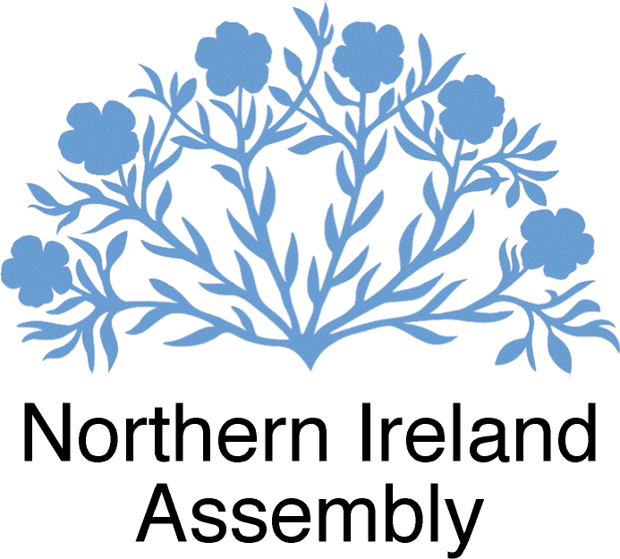

COMMITTEE FOR COMMUNITIES

MINUTES OF PROCEEDINGS

Thursday 25 June 2020
Room 29, Parliament Buildings

Present: Paula Bradley MLA (Chairperson)
Kellie Armstrong MLA (Deputy Chairperson)
Andy Allen MBE MLA
Mark Durkan MLA
Jonathan Buckley MLA
Sinéad Ennis MLA

Present: Teleconference Fra McCann MLA
Robin Newton MBE MLA

In Attendance: Kevin Pelan (Assembly Clerk)
Sean McCann (Assistant Assembly Clerk)
Antoinette Bowen (Clerical Supervisor)

The meeting commenced in open session at 10:04 a.m.

- Apologies

There were no apologies to record.

- Chairperson’s Business

The Chairperson reminded Members that, at the meeting on 17 June, they raised queries about the publication of the reclassification of housing associations consultation report.

The Chairperson advised Members that they had been provided with a departmental response and they would receive a briefing at today’s meeting.

Agreed: The Committee agreed to revisit Chairperson’s Business later in the meeting to facilitate the departmental briefing.

The Chairperson advised Members that the Minister had requested a meeting with herself and the Committee Clerk and this would take place on Friday 26 June. It was hoped that this would be a regular meeting.

The Chairperson advised Members that she has agreed as Chair to provide a Q and A article for Agenda NI, and that a copy of the article would be circulated to Members for information.

- Draft Minutes

Agreed: The Committee agreed the minutes of the meeting held on Wednesday 17 June 2020.

- Matters Arising

The Chairperson informed members that they had been provided with a copy of the Thirteenth report of the Examiner of Statutory Rules.

The Examiner stated that SR 2020/87 - The Social Security (Coronavirus) (Electronic Communications) (Amendment) Order 2020 had breached the 21day. However, the Examiner was content with the Department’s explanation for this which was the impact of the Covid-19 outbreak. Members agreed to note the Report.

Members noted a response from the Minister of Education to Committee queries on the pre-schools admissions process.

Members noted a departmental response to Committee queries on additional council funding.

The Chairperson advised Members that they had been provided with a response from the British Medical Association (BMA) to Committee queries on shielding letters.

Agreed: The Committee agreed to write to the department welcoming the Minister’s announcement for the continued provision of food parcels for those still shielding and to recognise the incredible work of organisations involved in provision of the service.

Members also agreed to highlight a number of concerns. In particular, the duplication in the distribution of food parcels and the inability for many of the most at need to avail of the service. Members noted that this was due to the schemes criteria which provided solely for those individuals with pre-existing conditions.

Members also agreed to ask the department to review the schemes criteria and administration to develop a more unified approach to the distribution process across all council areas.

The Chairperson advised Members that they had been provided with a departmental response to Committee queries on Universal Credit.

Agreed: The Committee agreed to write to the department welcoming the review of Universal Credit and to seek details of specific areas that they will be considering within the review.

- Departmental briefing on the outcome of the Liquor Licensing Laws Survey Report
The following interest was declared:

Mark Durkan MLA declared an interest due to family business.
The following departmental officials joined the meeting via teleconference at 10:17 a.m.:

Mr Liam Quinn, Social Policy Unit, Urban Regeneration Strategy Directorate
Mr Anthony Carleton, Director, Local Government and Housing Regulation
Ms Carol Reid, Social Policy Unit
The departmental officials provided the Committee with an overview of the outcome of the Liquor Licensing Laws Survey Report.

The oral evidence was followed by a question and answer session.

Agreed: Members agreed to write to the Minister welcoming the Bill and to advise that the Committee would comment in full once they had consulted stakeholders.

The Chairperson thanked the departmental officials for their attendance.

- Arts Collaboration Network briefing on the impact of Covid-19 on the Arts Sector
The following representatives joined the meeting via teleconference at 11:02 a.m.:

Ms Margaret Henry, thrive
Mr Sean Kearns, Actor
Ms Anne McReynolds, Chief Executive, The MAC

The representatives provided the Committee with an overview of the impact of Covid-19 on the Arts Sector.

The oral evidence was followed by a question and answer session.

Agreed: The Committee agreed to write to the Minister in support of the proposal for a Cultural Sector Recovery Plan, encouraging a collaborative approach to ensure its survival and to ask what measures are in place to support the Arts Sector in returning to sustainability.

Members also agreed to support any future bid for funding by the Minister to enable the sector to play a vital role in Northern Ireland’s economic and social recovery.

Agreed: The Committee agreed to write to the to the Executive Office asking that they write to the Chancellor of the Exchequer to provide a support scheme to assist in the revitalisation and sustainability of the Arts Sector in NI.

- Chairperson’s Business (continued)
The Chairperson advised Members that they would receive a departmental briefing on its response to Committee queries on the Housing (Amendment) Bill.

The following departmental official joined the meeting via teleconference at 11:48 a.m.:

Mr Paul Price, Director of Social Housing Policy & Oversight.

The departmental official briefed members on the department’s response to Committee queries on the Housing (Amendment) Bill.
The oral evidence was followed by a question and answer session.

Agreed: Members agreed to request a briefing from departmental officials and representatives from the Northern Ireland Housing Executive.
Robin Newton MBE MLA left the meeting via teleconferencing at 12:19 p.m.

The Chairperson thanked the departmental official for his attendance.

- Consideration of Secondary Legislation

SL1 – The Local Government (Accounts and Audit) (Coronavirus) (Amendment) Regulations (NI) 2020

Agreed: The committee agreed that it was content for the rule to be made.

- Correspondence

The Committee considered a request from Retail NI to brief on the regeneration of town and city centres following the Covid-19 crisis.

Agreed: Members agreed to invite Retail NI to brief the Committee at a future meeting.

The Committee considered a request from Northern Ireland Union of Supported Employment (NIUSE) to brief on future programmes and funding for the Disability Employment Sector and the impact of COVID-19.

The Committee also considered correspondence from the Committee for the Economy to the Minister for the Economy which followed a briefing from NIUSE seeking support for the Supported Employment Sector.

Agreed: Members agreed to invite NIUSE to brief the Committee at a future meeting.

Agreed: Members agreed to write to the Economy Minister supporting cross-departmental cooperation, to encourage the Minister to engage with colleagues on this issue, and to look at innovative provision for people with disabilities.

The Chairperson advised Members that a request to brief the Committee was also received from the Campbell-Tickell Homeless Sector Covid-19 Liaison Manager, working with the homelessness sector providers and the NIHE.

Agreed: Members agreed to invite homelessness service providers to brief the Committee at its meeting on 1 July.

The Committee noted the following:
- Copy of evidence, Covid-19; the challenge of recovery, submitted by the Institute of Theatre Consultants to the UK Parliament Committee for Culture, Media and Sport.

- Update on Social Security legislation to be taken forward by DWP.

- Details of House of Lords International Agreements Sub-Committee Inquiry on UK-US Trade Negotiations.

- Copy of updated Guidance for Social Housing Tenants and Landlords.

- Forward Work Programme

Members noted that, at the meeting on 1 July, the committee will be briefed by the Homelessness Sector on the Supporting People programme. Solace will also provide an update briefing on Covid-19 funding to local councils.
- Any Other Business

A member raised concerns regarding the lack of clarity on the reopening of gyms and other leisure facilities as lockdown restrictions continue to ease for other business areas.

Agreed: The Committee agreed to write to the Minister seeking clarification on the reopening of gyms and leisure facilities.

- Date, Time and Place of the next meeting

The next meeting will be on Wednesday 1 July at 14:00 p.m. in Room 29, Parliament Buildings.

The meeting went into closed session at 12:35 p.m.

The meeting adjourned at 12:45 p.m.

Ms Paula Bradley MLA
Chairperson, Committee for Communities

