Emailed to

11 February 2021

To whom it may concern

Climate Change Committee Advice for NI in relation to the 2050 emissions reduction target
You will be aware that the Climate Change Committee (CCC) recently wrote to the DAERA minister providing advice relating to a fair contribution to the UK Net Zero target and reductions by 2030. That advice is available on the CCC website at the following link
https://www.theccc.org.uk/wp-content/uploads/2020/12/Lord-Deben-CCC-Letter-to-DAERA-Minister.pdf
The Committee for Agriculture, Environment and Rural Affairs (AERA Committee) has considered this advice and has subsequently arranged to hear from CCC on 4th March 2021.
The AERA Committee has also received a follow up letter from DAERA on this advice. That letter has been published on the AERA Committee website and a copy can be found here http://nia1.me/4fk.
The AERA Committee will be hearing from CCC on the morning of 4th March. To inform that discussion it is asking if you are able to provide it with a short written brief on both the CCC letter and DAERA response by 12 noon Wednesday 24th February
You may also wish to note that it will also hear from DAERA on the morning of 18th February on an update on the Climate Change Bill Discussion Document consultation, and policy proposals for the draft Climate Change Bill.
I would be much obliged if you would please keep your response to no more than three A4 pages. I would also ask you to note that it is expected that the AERA Committee will have significantly more engagement on Climate Change in the forthcoming months.
Please note that all the AERA Committee meetings are broadcast and can be watched on the following link
https://niassembly.tv/calendar/

Yours sincerely
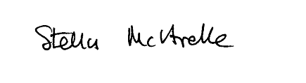
Stella McArdle
Clerk, Committee for Agriculture, Environment and Rural Affairs

